|  |
| --- |
| CROSS-ENTERPRISE DOCUMENT SHARING (XDS) IMPLEMENTATION BASED ON BLOCKCHAIN TECHNOLOGY  PETNATHEAN JULLED 5936474  ABSTRACT  On the increasing demand for a better quality of healthcare services, some topics involve healthcare information technology in terms of operational efficiency. Healthcare information sharing and interoperability between healthcare organizations are one of the major solutions to improve healthcare service quality. However, the healthcare industry poses many challenges that inhibit solutions to become reality. The Integrating Healthcare Enterprise (IHE) initiative to standardize healthcare information sharing methods to address health document sharing issues between different enterprises, Cross-Enterprise Document Sharing (XDS.b) Profile allows the adopted organizations to share health documents simultaneously using the central exchange.  Like other industries, cyber-security threats have threatened the healthcare information domain. These threats increase the difficulty in the development of health information sharing networks and causing damage to healthcare enterprises. These cyber-threats can cause damage to the industry in many aspects, especially those cyber-attack that targeting integrity and availability of data. These kinds of cyber-attacks can severely hinder the continuity of medical operations, potentially resulting in the cost of a patient’s life. There are many solutions technology proposed to deal with these kinds of cyber-attacks. One of the technologies that are the trend to deal with cyber-threats threatening integrity and availability of data is Blockchain technology.  Several pieces of research have proposed the concept of using Blockchain technology to solve health information sharing issues but, there are still many limitations that prevented Blockchain technology from effectively integrated with data like health information. This is where the IHE XDS.b profile could be used with Blockchain technology to allow health document sharing through the decentralized networks while address cyber-security issues through unique characteristics of Blockchain technology. In this work, we propose the approach for integrating Blockchain technology with the IHE XDS.b profile which results in the new concept of health information exchange.  KEY WORDS: HEALTH INFORMATION / INTEROPERABILITY / INFORMATION SHARING / INFORMATION SECURITY / BLOCKCHAIN / SMART CONTRACT / IHE / XDS  298 pages |

CHAPTER I

INTRODUCTION

With the transition from the age of paperwork to digital records, the healthcare industry is now undergoing digital transformation. Efficiency and continuity are the main factors that driven the healthcare industry to change. Paperwork starts falling behind when a huge amount of data is produced by healthcare service operations from day to day. Health information undeniably has become an important component in developing efficient healthcare services [1–6]. On the increasing demand for the better quality of healthcare service, there is the topic that involves healthcare information technology in terms of operational efficiency. Healthcare information sharing and interoperability between healthcare organizations are one of the major solutions to improve healthcare service quality. Patient’s health document data are scattered across different healthcare organizations, due to the foundation of healthcare informatics are separately developed by different organizations. Each healthcare organization has its own method to process and handle healthcare information. This makes it hard for one healthcare piece of information to interoperate with other. Lack of interoperability prevents many opportunities for healthcare service quality improvement. The patient may need to take extra repetitive care procedures when visiting a new hospital. Mistakes in communication between different physicians can cause misdiagnosis. So, there are many demands from the patient side that want their health journey to be connected and improve healthcare service quality.

To enable health information sharing from just one organization with another can cost much more than the benefit they can gain. Sharing health information with not fully-trusted party exposing vulnerabilities to the business model. The risks and benefits to the organization from sharing their patient information with others may not be worth it as compared to the risk. For example, health information sharing allows the physician to access a patient's health history in other hospitals give decent improvement to service quality, in turn, exposing the information access to cyber-criminal and provide a chance for business competitors to gain an advantage. This creates high friction for one organization to share their information with others. It was even more difficult for an individual patient to integrate their healthcare with different providers. This makes the interoperability issue to be extremely difficult for every single organization to solve on its own. It revealed that these interoperation problems cause a huge decrease in inefficiency in healthcare operations and result in lower quality of healthcare service [7–14]. But there is still no efficient way to be best solve the problem yet. That means there still have an open issue on how to solve interoperability in the field of healthcare. [7,9–11]

That way many initiatives start to standardize healthcare information technology to allow healthcare organizations to be able to interoperate with each other. Integrating Healthcare Enterprise (IHE) is one of the well-known initiatives that provide specifications for using healthcare informatics standardization. IHE provides an implementation framework and guideline for developing a health informatics system. For health document sharing between different organizations, IHE provides a Cross-Enterprise Document Sharing (XDS.b) profile. The profile act as a guideline for the system developer to implement their system to meet the requirement where the system can share health document with other organizations. This profile will be the main focus of this work, to deal with the health information sharing problem.

In the current age of information digitalization, cybersecurity has become an important issue for many organizations and individuals. Anyone can become a target of cyber-attacks. The healthcare industry is one of the major targets that become a victim of cyber-attacks each year [15]. Followed by the digitalization of hospital operations and information systems, the amount of cyber-attack and variations rise as the technology developed. These incidents variant from breaches in personal health information to the larger size of attacks which can potentially halt hospital operations that cause damage in various kinds. It may cost the hospital more than a million, or even cost individuals’ life because of the incident for the worst.

There are many kinds of incidents targeting the healthcare industry. In recent years, one of the major incidents found throughout the industry is a hospital data breach. Data breaches often appeared in the form that hospital data got compromised by hackers. The compromised data can be valuable in the criminal world as it can be used for various kinds of criminal activities like identity theft, blackmailing, or social engineering because the data may include patients’ personal information and their health condition. This kind of incident can potentially cost hospitals ‘a trust’ issues from their patients, as individuals’ medical conditions and privacy are being exploited. Also, there is the case that not just gain unauthorized access to patient’s private data but, take over the data or even wipe all important data out of existence. ‘Ransomware’ and ‘Wipeware’ are the main cause of these threats. Ransomware takes over ownership over data away from the hospital system and encrypts all the data which often takes an important role in hospital operation. At the same time, Wipeware will delete all the data from the victim machine. This mostly causes great disruption in hospital operation as consequence. Incidents that showed up in recent years seem to target healthcare organization more frequently, as the industry still have poor cybersecurity practices [16]. Many incidents [16–18] showed that social engineering launched on healthcare employees is on rising. The threat has the potential to seamlessly blend into hospital workflow and made it hard to be noticed. However, follow these incidents, many stakeholders in the healthcare domain start to implement cyber-security to their organization infrastructure.

At the foundation, each organization must start with educating their employees on cyber-security awareness to reduce the risk of cyber-incident that may cause by human error or human vulnerabilities. Next, define organization policy and management plan that help prepare against cyber-incident. When employees and management level of organization have prepared cyber-security, the organization will focus on cybersecurity of the technology layer. There is various kind of tools and technology that was invented to mitigate cyber-incidents. Some may have been made to prevent exploitation of existing technology while some may have been made to directly deal with known and upcoming threats.

One of many concepts invented to mitigate these threats is the decentralization of data. The concept of decentralization was made to mitigate most incidents and threats that involve single-point of failure vulnerability. In the case of the healthcare industry where the loss of patient data can cause many major damages to the affected organization and their patient, decentralization of data can help reduce damage caused by the case. There is more than one benefit that healthcare document data can gain from decentralization. Decentralization allows patient data that scattered across healthcare domains in different organizations to link to each other. As healthcare document data can be scattered across the different organizations within the healthcare industry, it also increases the chance that its copies can survive cyber-incidents. Even in case, that document in one organization got compromised, there is a chance that copies of compromised data also exist in other organizations. The survived copies can make a substitute for the original that got compromised. However, this only possible if there is a point that lets every organization in the network known which document exists in which organization. This is where the concept of the IHE Cross-Enterprise Document Sharing Profile fits in. Combined with Blockchain technology that makes the Document Registry entry persist and immutable, this ensures that every organization in the network will always know the whereabouts of document they need within the network while the entry itself cannot be tempered or deleted by any actor with ill intention.

This work will introduce another way to allow health document sharing between healthcare organizations with increased protection against cyber-threats, by using a combination of Blockchain and IHE Cross-Enterprise Document Sharing (XDS.b) Profile.

**1.2** **Problem Statement**

There is no reliable software platform that supports securely and confidentially sharing healthcare documents between healthcare systems and organizations. The platform must allow sharing of healthcare documents between different healthcare organizations while still maintaining the confidentiality of data and also help mitigate emerging cyber-threats in the healthcare domain that tend to tamper with integrity and availability of data. The platform must act as the health document exchange medium that has distributed, decentralized, persistent, confidential, and immutable availability characteristics.

**1.3** **Objective**

1.3.1 Design and implement Document Registry Blockchain shall follow the requirement for document registry defined in the XDS.b integration profile from IHE.

1.3.2 Design and implement Blockchain smart contract shall provide the main function to Document Registry Blockchain as healthcare document registry which comprises of health document registering function and health document search function.  
 1.3.3 Design and implement Blockchain smart contract shall have additional function to record healthcare document exchange between participate node.  
 1.3.4 Deploy and evaluate the functionality of Document Registry on Blockchain.

**1.4** **Scope of Project**

1.4.1 Design and implementation of Document Registry Blockchain shall follow requirements defined in XDS.b integration profile from IHE.  
 1.4.2 Design and implementation of Blockchain smart contract within Document Registry Blockchain that gives the main function as healthcare document registry and additional function as healthcare document exchange history record.

**CHAPTER II**

**LITERATURE REVIEWS**

**2.1** **Integrating the Healthcare Enterprise (IHE)**

Integrating Healthcare Enterprise initiative (IHE) is an initiative founded by RSNA and HIMSS working closely with healthcare industry with the objective to improve the way computer systems in healthcare integrate and share their information. IHE promotes the coordinated use of established standards such as DICOM and HL7 to address specific clinical needs in support of optimal patient care. Systems developed in accordance with IHE communicate with one another better, are easier to implement and enable care providers to use information more effectively. This helps enables accessibility to health information that is usable whenever and wherever needed. The initiative is responsible for providing specifications, tools, and services for interoperability. They also engage clinicians, health authorities, industry, and users to develop, test, and implement standards-based solutions to vital health information needs [19]. The initiative provides a convenient and reliable way of specifying a level of compliance to standards sufficient to achieve truly efficient interoperability.

**2.1.1** **IHE Process**

Figure 2‑1 show the IHE Process where the initiative brings together users and developers of healthcare information technology in an annually recurring four-step process. The process started with clinical and technical experts define critical use cases for information sharing then followed by technical experts create detailed specifications for communication among systems to address these use cases. IHE participants also select and optimize established standards during this step. After that, the industry implements these specifications which would be called “IHE Profile” into their healthcare information technology system. The initiative then tests these implemented systems at carefully planned and supervised events called “Connectathons” to ensure that the resulting implementation of IHE Profiles will provide benefit for the implementer and make their works compatible with others in the healthcare industry. The initiative committees follow the four-step annual process as shown in Figure 2‑1 to address interoperability in a variety of clinical domains. They have worked in various areas including Cardiology, Dental, Devices, Endoscopy, Eye Care, Information Technology Infrastructure, Pathology and Laboratory Medicine, Patient Care Coordination, Pharmacy, Quality, Research, and Public Health, Radiation Oncology, Radiology, Surgery.

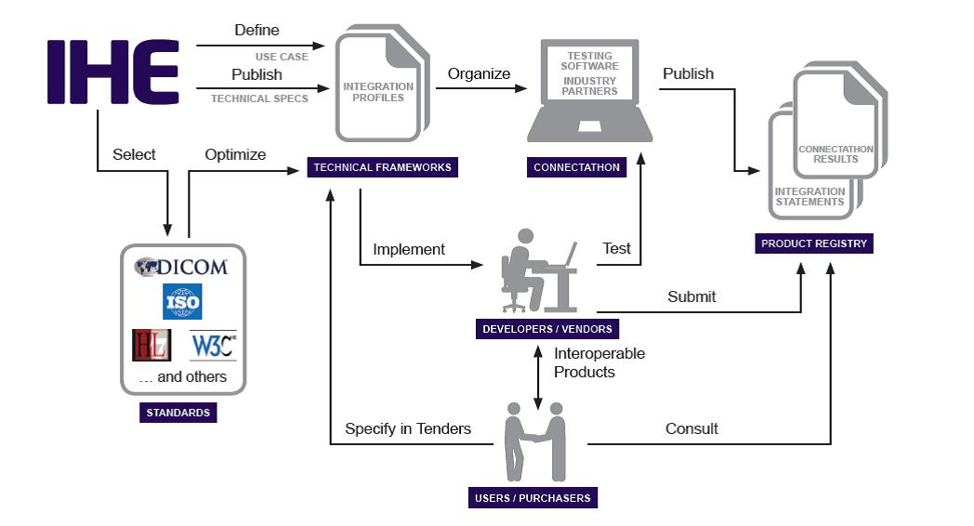

Figure ‑ IHE Process to create guideline for implementation of health information technology [20]

**2.1.2** **IHE Integration Profiles**

IHE Integration Profiles or IHE Profile are products of the IHE Process which provide a standards-based framework for sharing information within care sites and across networks. They address critical interoperability issues related to information access for the care given to providers to patients in an area of clinical workflow, security, administration, and information infrastructure, etc. IHE Profile was purposely designed to offer a clear implementation path for IT developers to develop and implement IT systems for a healthcare organization that meets the needs and compatible with the environment of the healthcare industry while also aiding them in dealing with various kinds of communication standards existing within the healthcare IT domain. These profiles organize and leverage the integration capabilities that can be achieved by the coordinated implementation of communication standards, such as DICOM, HL7 W3C, and security standards. They provide precise definitions of how standards can be implemented to meet specific clinical needs. [21] Each profile specifically defines the actors, transactions, and information content required to address the clinical use case by referencing appropriate standards. IHE Profiles that have undergone IHE Process, sufficient testing, and deployment in real-world care settings and have reached final text (approved) status, will be published in specification documents called "IHE Technical Frameworks" (IHE TF). There is one Technical Framework per IHE clinical domain, with each framework comprised of multiple volumes. The Technical Frameworks provide detailed explanations for each IHE Profile specified by their interoperability issues and dependencies among the Integration Profile.

**2.1.3** **IHE Information Technology Infrastructure Technical Framework**

IHE IT Infrastructure Technical Framework (ITI TF) defines specific implementations of established standards to achieve integration goals that promote appropriate sharing of medical information to support optimal patient care. It is expanded annually, after a period of public review, and maintained regularly through the identification and correction of errata. The framework identifies a subset of the functional components of the healthcare enterprise, called IHE actors, and specifies their interactions in terms of a set of coordinated, standards-based transactions. It describes this body of transactions in progressively greater depth. The framework is divided into four volumes. The first volume describes concept detail of IHE ITI Integration Profiles. The second volume divided into four sub-volumes; a, b, c, and x which describe concept detail of all transactions present in the framework. The third volume provides further explanation into the specifications of cross-transaction and content used in Document Sharing Profiles. The fourth volume provides additional national extensions related to the framework.

**2.1.4** **Cross-Enterprise Document Sharing Set-b (XDS.b) Profile**

The Cross-Enterprise Document Sharing Set-b (XDS.b) IHE Integration Profile facilitates the registration, distribution and access across health enterprises of patient electronic health records. [22] The profile is focused on providing a standards-based specification for managing the sharing of documents between any healthcare enterprises, ranging from a private physician office to a clinic to an acute care in-patient facility. XDS is generic term to reference all XDS profiles which are Cross-Enterprise Document Sharing Profiles. XDS.a and XDS.b are implementation profiles that describe technically how the implementation will be done. XDS-I is an XDS implementation specifically for medical imaging [23]. In IHE IT Infrastructure Technical Framework Vol.1 latest published in 2018 declared that term XDS within the ITI Technical Framework refers generically to any flavor of XDS, currently only XDS.b [22]. The main goal of XDS.b profile is to allow XDS Affinity Domain members to share health document via XDS Document Registry. That mean, its process mainly about make metadata of document within XDS Document Repository available on XDS Document Registry entry. This allow any XDS Document Consumer to visit XDS Document Registry and seek for the document they need, before retrieve it from the XDS Document Repository that the document belong to.

The process overview of Cross-Enterprise Document Sharing (XDS.b) profile is described in Figure 2‑2. The figure also showed sequence of process along with involving XDS actors and XDS transaction format. At the beginning, each health document will be created from its sources along with its metadata attributes. These sources will be called ‘XDS Document Source actor’ which can be any machine involved in healthcare service, for example; CT scanner, laptop in each physician office, or central computer in medical lab. Next, these created documents along with its metadata will be sent to data storage which act as document repository. These repositories will be called ‘XDS Document Repository actor’ which usually be some kind of computer or server that was assigned to keep medical document available for use. According to XDS.b profile, XDS Document Source will send document metadata in the format of Provide and Register Document Set-b (ITI-41) format. In some case, XDS Document Source and XDS Document Repository may integrated together. This is called ‘XDS Integrated Document Source Repository actor’. The XDS Integrated Document Source Repository functions the same way as XDS Document Source and XDS Document Repository will do but, combined together.

After the document and its metadata was sent to XDS Document Repository, the repository will index and make the document available for usage. At the same time, XDS Document Repository registers metadata along with identifier and locator of the repository itself to local document registry. The message transaction in this process will follow format of Register Document Set-b (ITI-42). The document registry will be called ‘XDS Document Registry actor’. XDS Document Registry is software or machine that keep all document metadata and its corresponding repository from all connected repositories available for discovery. Commonly, XDS Document Registry should be database that keep document metadata from all connected repositories available for discovery through database query. However, there are no restriction from XDS.b profile for method to keep these data and how to discover each document metadata using specified document metadata attributes. There are just requirement that require XDS Document Registry to be able to accept value of specified document attributes from XDS Document Consumer and return the matched document to the consumer.

In XDS.b profile, ‘XDS Document Consumer actor’ can be any kind of software or machine that allow user like healthcare employees to access health document or medical document they need. There are no restriction in XDS.b profile that specified XDS Document Consumer actor to be different software or machine from other actors. XDS Document Consumer actor will just require user to specify value of known document metadata attributes which will allow XDS Document Repository to search for matching document metadata in its database. After received document attributes value from its user, XDS Document Consumer actor will send the specified attributes to XDS Document Registry. This message transaction will follow format of Registry Stored Query (ITI-18). Then, XDS Document Registry process received attributes by search for matching document metadata and return full document metadata which it found to XDS Document Consumer. XDS Document Consumer actor show founded result to its user. The user pick the right document they need and issue to XDS Document Repository corresponding to the document for document retrieval via XDS Document Consumer actor. XDS Document Consumer will send document retrieval request transaction in the format of Retrieve Document Set-b (ITI-43). After XDS Document Repository received document retrieval request from XDS Document Consumer, the repository will seek for the specified document and return the document to XDS Document Consumer. XDS Document Consumer actor will make the retrieved document available for user to use.

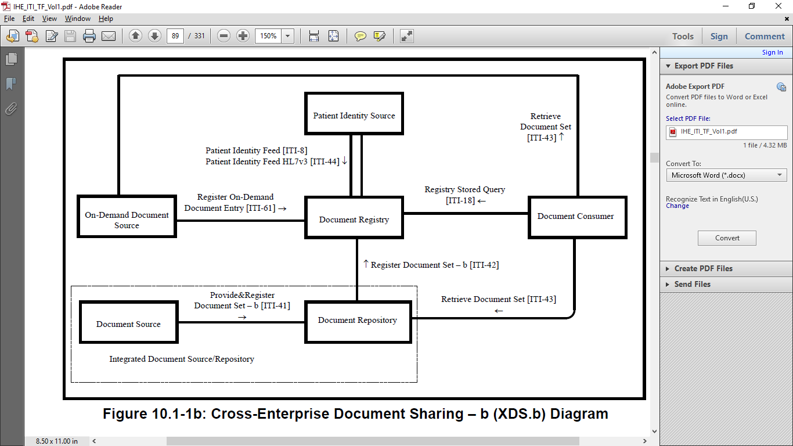

Figure ‑ Cross-Enterprise Document Sharing - b Diagram [22]

**2.1.5** **XDS Transaction Format Types**

In XDS.b profile, all messaging transaction will be in the form of XML format with schema depend on each types of transaction. Types of XDS transaction format vary upon involving actors and its purpose.

2.1.5.1 Provide and Register Document Set – b (ITI-41)

Provide and Register Doccument Set – b (ITI-41) transaction format defines XML schema for message that sends metadata of document from XDS Document Source actor to XDS Document Repository actor for store into document repository. This type of transaction mainly requires XDS Document Source to include all available metadata attributes of created document for other XDS actor. XDS Document Repository actor would need to acknowledge to XDS Document Source if it successfully received document and its metadata.

2.1.5.2 Register Document Set – b (ITI-42)

Register Document Set – b (ITI-42) defines XML schema for message that sends metadata of available document in repository from XDS Document Repository actor to XDS Document Registry actor to register the document into document registry entry. Main purpose of this type of transaction is to pass document metadata stored in repository to XDS Document Registry actor addition with attributes about the repository. XDS Document Registry actor will need to respond back to XDS Document Repository actor when received the transaction and register it to document registry entry.

2.1.5.3 Registry Stored Query (ITI-18)

Register Stored Query (ITI-18) is general XML schema format that used by one actor to query for data from other actor in entire IHE IT Infrastructure Framework. In this work, the transaction will be used by XDS Document Consumer actor to request for document metadata it seek from XDS Document Registry actor. Any document metadata attributes known by XDS Document Consumer will be included in the transaction. XDS Document Registry will use specified metadata attributes to search for matching document metadata inside document registry entry. XDS Document Registry will need to respond to XDS Document Consumer actor that it received the request. XDS Document Registry also needs to return search result to XDS Document Consumer.

2.1.5.4 Retrieve Document Set (ITI-43)

Retrieve Document Set (ITI-43) define XML schema for XDS Document Consumer to request document retrieval from XDS Document Repository. Different to other transactions involved in XDS.b profile, Retrieve Document Set transaction only contain few essential attributes to allow retrieval of document from document repository. XDS Document Repository will need to acknowledge to XDS Document Consumer when received the transaction before return the requested document.

**2.1.6** **Transaction Object Type and Metadata Attributes**

In each transaction, there are set of metadata attributes that represent the document. These metadata attributes are categorized to three sections. SubmissionSet (Table 2‑1) represent information associated with submission of document since it was created by the source. Folder (Table 2‑2) represent group that the document belongs to. DocumentEntry (Table 2‑3) represent the document itself.

2.1.6.1 SubmissionSet

Table ‑ SubmissionSet Metadata Attributes

|  |  |
| --- | --- |
| **SubmissionSet Metadata Attributes** | **Description** |
| author | The humans and/or machines that authored the SubmissionSet. This attribute contains the sub-attributes: authorInstitution, authorPerson, authorRole, authorSpecialty, authorTelecommunication. |
| availabilityStatus | The lifecycle status of the SubmissionSet. |
| comments | Comments associated with the SubmissionSet. |
| contentTypeCode | The code specifying the type of clinical activity that resulted in placing the associated content in the SubmissionSet. |
| entryUUID | A globally unique identifier used to manage the entry. |
| homeCommunityId | A globally unique identifier for a community. |
| intendedRecipient | The organizations or persons for whom the SubmissionSet is intended. |
| limitedMetadata | A flag that the associated SubmissionSet was created using the less rigorous metadata requirements as defined for the Metadata-Limited Document Source. |
| patientId | The patientId represents the primary subject of care of the SubmissionSet. |
| sourceId | Identifier of the entity that contributed the SubmissionSet. |
| submissionTime | Point in time at the creating entity when the SubmissionSet was created |
| title | The title of the SubmissionSet. |
| uniqueId | Globally unique identifier for the SubmissionSet assigned by the creating entity. |

2.2.6.2 Folder

Table ‑ Folder Metadata Attributes

|  |  |
| --- | --- |
| **Folder Metadata Attributes** | **Description** |
| availabilityStatus | The lifecycle status of the Folder. |
| codeList | The set of codes specifying the type of clinical activities that resulted in placing DocumentEntry objects in the Folder. |
| comments | Comments associated with the Folder. |
| entryUUID | A globally unique identifier used to manage the entry. |
| homeCommunityId | A globally unique identifier for a community. |
| lastUpdateTime | Most recent point in time that the Folder has been modified. |
| limitedMetadata | A flag that the associated Folder was created using the less rigorous metadata requirements as defined for the Metadata-Limited Document Source. |
| patientId | The patientId represents the primary subject of care of the Folder. |
| title | The title of the Folder |
| uniqueId | Globally unique identifier for the Folder. |

2.2.6.3 DocumentEntry

Table ‑ DocumentEntry Metadata Attributes

|  |  |
| --- | --- |
| **DocumentEntry Metadata Attributes** | **Description** |
| author | The humans and/or machines that authored the document. This attribute contains the sub-attributes: authorInstitution, authorPerson, authorRole, authorSpecialty and authorTelecommunication. |
| availabilityStatus | The lifecycle status of the DocumentEntry |
| classCode | The code specifying the high-level use classification of the document type (e.g., Report, Summary, Images, Treatment Plan, Patient Preferences, Workflow). |
| comment | Comments associated with the document. |
| confidentialityCode | The code specifying the level of confidentiality of the documented. |
| creationTime | The time the author created the document. |
| entryUUID | A globally unique identifier used to manage the entry. |
| eventCodeList | This list of codes represents the main clinical acts, such as a colonoscopy or an appendectomy, being documented. |
| formatCode | The code specifying the detailed technical format of the document. |
| hash | The hash of the contents of the document. |
| healthcareFacility TypeCode | This code represents the type of organizational setting of the clinical encounter during which the documented act occurred. |
| homeCommunityId | A globally unique identifier for a community. |
| languageCode | Specifies the human language of character data in a document. |
| legalAuthenticator | Represents a participant within an authorInstitution who has legally authenticated or attested the document. |
| limitedMetadata | Indicates whether the DocumentEntry was created using the less rigorous requirements of metadata as defined for the Metadata-Limited Document Source. |
| mimeType | MIME type of the document. |
| objectType | The type of DocumentEntry (e.g., On-Demand DocumentEntry). |
| patientId | The patientId represents the subject of care of the document. |
| practiceSettingCode | The code specifying the clinical specialty where the act that resulted in the document was performed (e.g., Family Practice, Laboratory, Radiology). |
| referenceIdList | A list of Identifiers related to the document |
| repositoryUniqueId | The globally unique identifier of the repository where the document can be accessed. |
| serviceStartTime | The start time of the service being documented. |
| serviceStopTime | The stop time of the service being documented. |
| size | Size in bytes of the document. |
| sourcePatientId | The sourcePatientId represents the subject of care’s medical record identifier (e.g., Patient Id) in the local patient identifier domain of the creating entity. |
| sourcePatientInfo | This attribute contains demographic information of the source patient to whose medical record this document belongs. |
| title | The title of the document. |
| typeCode | The code specifying the precise type of document from the user perspective (e.g., LOINC code). |
| uniqueId | Globally unique identifier assigned to the document by its creator. |
| URI | The URI for the document. |

**2.2** **Blockchain Technology**

**2.2.1** **Definition of Blockchain**

Blockchain is a list of records, or “blocks”, that are linked to one another and cryptographically secured [24]. Blockchain is a technology that allows data to be stored and exchanged on a peer-to-peer basis. Structurally, Blockchain data can be consulted, shared and secured thanks to consensus-based algorithms [25]. Blockchain is a sequence of blocks, which holds a complete list of transaction records like conventional public ledger [26]. Participants in a Blockchain network have records of every transaction and these records are stored locally on the computers of all participants in that Blockchain network. Any kind of regime or protocol change to a Blockchain network requires consensus between the users of the network. In 2008, the Blockchain idea was combined with several other technologies and computing concepts to create modern cryptocurrencies which is electronic cash protected through cryptographic mechanisms instead of a central repository or authority.

This technology became widely known in 2009 with the launch of the Bitcoin network as the first widely known Blockchain network with its purpose as cryptocurrency, followed by multi-purpose Blockchains like Ethereum and many other platforms with their own applications. For cryptocurrency Blockchain like Bitcoin, the transfer of digital information that represents electronic cash takes place in a distributed system. Bitcoin users can digitally sign and transfer their rights to that information to another user and the Bitcoin Blockchain records this transaction into Blockchain's distributed ledger, make it available for public verification. Blockchain was designed to defy the concept of having a single centralized system as the host of the network which subsequently allow the concept of decentralization to take the place by having many members of the network to equally maintain the replicated distributed ledger. Combined with the cryptographically hashed "Block" and "Chain" concept, makes the Blockchain resilient to any attempts to alter information recorded in the distributed ledger. With the contribution of the Blockchain developer community, the technology now available for a variety of applications and being researched for a variety of further usage in many industries. [27]

According to the document “Blockchain Technology Overview” [27] which published by National Institute of Standards and Technology from U.S. Department of Commerce, Blockchain can be informally define as: A distributed digital ledgers of cryptographically signed transactions that are grouped into blocks. Each block is cryptographically linked to the previous one (making it tamper evident) after validation and undergoing a consensus decision. As new blocks are added, older blocks become more difficult to modify (creating tamper resistance). New blocks are replicated across copies of the ledger within the network, and any conflicts are resolved automatically using established rules.

**2.2.2** **Benefit of Blockchain**

Blockchain tampers evident and tamper-resistant digital ledgers implemented in a distributed fashion and usually without a central authority. At their basic level, they enable a community of users to record transactions in a shared ledger within that community, such that under normal operation of the Blockchain network no transactions can be changed once published [27].

**2.2.3 Blockchain Characteristics**

Key characteristics of the Blockchain can be vary depend on its setup and environment of usage. According to many sources, key characteristics of the Blockchain may be summarized as followed:

2.2.3.1 Decentralization

Decentralization is the foundation of Blockchain technology as response to problem of centralized system. In centralized system, especially centralized database, there is a chance that the database got compromised by hacker. Other than rely on backup data, there are very few options to deal with the incident. This makes the compromised database become single point of failure which prevent follower system to operate. Decentralization of data was proposed to scatter the chance of single database from getting compromise. This makes decentralized database network have more resistant against incident threatening centralized data. Even hit by incident that aims to compromise the data. If at least half of decentralized network survived the incident, the data survives the attack.

2.2.3.2 Immutable

With utilization of cryptographically hashed chain combined with decentralized network, the Blockchain technology ensures that any data published on Blockchain cannot be deleted or modified. If there are any modification made to content of published data, it will cause change on the hash chain and detected the network. Any action that causes change to hash chain will be negate by majority of the network. This mean if anyone want to temper with published data on Blockchain, they will need to compromise the entire network at once. Any survived node has chance to notify the abnormal to the entire network.

2.2.3.3 Transparency

As the foundation of Blockchain is to have all participant nodes have the exact same copy of Blockchain ledger, it passively gives transparency to published data. It is impossible for anyone to secretly hide something inside Blockchain without let other participants in the Blockchain network know.

2.2.3.4 Distributed

Blockchain has distributed characteristic by design. All nodes will have the same Blockchain ledger. Any contents published to Blockchain ledger are passively distributed to all Blockchain node. With consensus algorithm, it requires that the publishing content either sent to all nodes before accepting to publish or being accepted then send to all node, to complete consensus. So, Blockchain ensures that any data published to the chain are distributed to all connected nodes.

2.2.3.5 Trusted

In public network where anyone can participate or in permissioned network where participants are not completely trust each other, trust is the main factor that define usability of decentralized network. Along with Blockchain technology, consensus solve the issue about trust by eliminate the chance of any single node participate in Blockchain to have absolute control over publishing data when certain condition is met. It can rely either on randomness or specially designed algorithm depend on each consensus method. When none of any single node can have absolute control over publishing data on the Blockchain, made it extremely difficult for someone to temper with target data. Many consensus methods ensure that it will much more expensive for anyone to attempt on tempering with publishing data when compared to benefit they can get. This passively establishes trust between all participant nodes.

**2.2.4 Blockchain Types**

When considering the scope of participants who can participate in a specific Blockchain network, Blockchain can be categorized into three types of Blockchain networks.

2.2.4.1 Public Chain

Public Blockchain is the type that allows anyone to participate in the network either participating as client/user node or miner/validator node. This type of Blockchain mostly has no specific rule, policy, or agreement for participants to enter the network. The type is suited best with the network environment where its data is not required to be kept confidential from the public.

2.2.4.2 Private Chain

Private Blockchain is the type that allows only a limited number of members to participate. This type was invented to be more compatible with the environment that participant nodes are members of a specific organization or community where the Blockchain ledger may record confidential information limited only to participants.

2.2.4.3 Permissioned Chain

Permissioned Blockchain is the type that allows only selected members of a specific community or affinity domain to participate, and it is also known as consortium Blockchain. Permissioned Chain is different from Private Chain in terms of scalability. As the private chain was limited for pre-selected members, the permission chain may further extend its member to a larger group of members via policy or agreement accepted by original participants. At the same time, the permission chain will not allow anyone to participate in the network as the Blockchain ledger may contain confidential information limited to the accepted group of participants.

**2.2.5 Blockchain Components**

2.2.5.1 Transaction and ‘Block’

Each of individual information represent change or cause of actions in information system are stored within Blockchain as “Transaction”. Several transactions being publish to Blockchain within the same time interval are put in the same “Block”. To form each single block, miner or validator needs to hash transaction together. The resulting hash value represents integrity of each block. If there are any change apply to transaction in the block, it will cause hash value of the block to change. Format of block vary depends on each Blockchain platform and its use case. Some platforms may publish in a form of plaintext just to act as the source of truth for every participating node to look without constraint. Some platforms may bound transaction or block to unique address to extend variation in accessibility. Some platforms may encrypt block to maintain confidentiality of data. Transaction and Block are the key component which determine purpose and application of Blockchain.

2.2.5.2 Cryptographically hashed ‘Chain’

Other than the concept of “Block”, The Blockchain concept also introduced the concept of “Chain. As integrity of each Block represent by its hash value, integrity of entire Blockchain represent by all hash value of all Block within “Chain”. The foundation of “Chain” concept is by chaining hash value of all blocks together. This can be done by include hash value of block formed in previous time interval into the current block to generate its hash value. Any changes made to any one single block will alter hash value of the entire chain that come after. This makes it harder to alter data that published within Blockchain. It requires anyone who want to alter the data to apply change to all blocks that come after the target block until the current one to make the change valid. Combined with decentralization characteristic of Blockchain network, this makes data exist in Blockchain nearly impossible to alter.

2.2.5.3 Distributed network of participate ‘Node’

Any machine that participates in the Blockchain network is called “Node”. Nodes represent the population of each Blockchain network. Each node keeps the same copy of data in Blockchain which is the Blockchain ledger and always tends to in sync with each other via Blockchain-specific protocol depend on each platform. In the case of Ethereum, the platform utilize devp2p protocol which allows each Ethereum node to connect with others at a peer-to-peer level [29]. If there are any differences in data between nodes, the version of data is being held by a minority of participating nodes. They will be clarified as false before rejected by the entire network and replaced by the right version accepted by the network. In each Blockchain network, some nodes may participate as "miners" or be elected as "validators" of the network at each different time interval. Miner/Validator nodes have a duty to perform the task which maintaining the consensus of the network. The Blockchain can be alive only if they are at least one participating node to maintain the Blockchain, while the strength of its characteristics depends on the number of participating nodes. In most cases, more participating nodes mean stronger Blockchain.

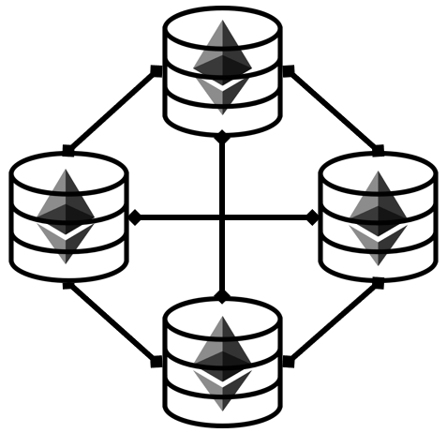

Figure ‑ Blockchain network formed from the participation of Blockchain nodes

2.2.5.4 Consensus

Each Blockchain network must have its own consensus within the network. Specifically, it is not just the consensus between the member but the built-in consensus mechanism within the communication protocol connects each member in the network. The consensus mechanism acts a vital role to ensure the integrity of the Blockchain ledger by ensuring that everyone in the network is holding the same copy of the Blockchain ledger and no one has full control over data adding to the Blockchain ledger or have the right to select which version of the Blockchain ledger for the network to maintain. There are many variations of consensus invented since the beginning of Blockchain technology. Each has its own method of investing resources to achieve complete consensus. The existing consensus concept at the time can be divided into three major types based on the participation of Blockchain members who declared to act as maintainers of the Blockchain ledger.

2.2.5.4.1 Competition-based consensus

The type was the first to introduced along with the beginning of Bitcoin Blockchain which called "Proof of Work" (PoW). The competition-based consensus like PoW requires Blockchain maintainer node (which was called "miner") to invest computational resources on competing with other miners to solve the specific mathematical puzzle which only computational power can effectively solve. The first miner who can solve the puzzle will have the right to add the adding Block to the Blockchain ledger and receive a reward declared by the network which would compensate the investment. In the case of PoW, a miner must randomly generate a correct "nonce" number that when hashing together with the hash value of the adding Block will result in a hash value with a digit of '0' beginning specified by the network (such as 0x0000000abcd). This kind of puzzle ensures that the chance where malicious actors want to attempt malicious activity on the specific transactions on certain Blocks is at least possible. Combined with the increase in the number of miners entering the competition given that chance becomes nearly impossible to achieve. This consecutively ensures the integrity of the Blockchain ledger and gives transparency to Blockchain. The scenario of competition-based consensus suited best to Public Blockchain where anyone can participate in Blockchain. The more miner entering the competition means the more reliability and transparency for the Blockchain. Additionally, the reward-based nature of the concept can even further synergize the Blockchain to have more miners participate in the network. However, due to the competition will have major of computational power invested in achieving consensus, that means the environment where computational power is limited and precious to its member will not be compatible with this type of consensus.

2.2.5.4.2 Randomness-based consensus

The type was originally introduced as an alternative to a competition-based consensus like PoW and to address the problem where major computational power will be wasted in achieving consensus. The concept proposes utilizing randomness to aid in the selection of the Blockchain maintainer at a certain time. Widely known consensus mechanisms that can be categorized to this type are "Proof of Stake" (PoS) and "Proof of Authority" (PoA) which using pseudo-random algorithm combined with additional factor to determine for the node that has the right to add Block to the Blockchain ledger at a certain time (which would be called "validator). Both PoS and PoA require validator candidate to place "the bet" on "the stake" which would mostly be cryptocurrency circulating in the network. The one with a higher bet put on a stake will have a higher chance to be selected as the validator of the time. However, there is still a chance that the one with a lower bet can be selected as the validator instead. The one that has been selected as the validator will gain all the bet placed on the stake. That means each candidate needs to take an equal risk to gain and loss their available bet. This consecutively results as distributed right amongst the network similar sense to what achieved in competition-based consensus.

As this type of consensus act as an alternative to competition-based consensus, that means the environment best suited with this type of consensus is where its member cannot effort to lose computational power in competition-based consensus altogether.

2.2.5.4.3 Majority-based consensus

This type of consensus was also introduced as another alternative to a competition-based consensus like PoW. The original concept of this consensus type was originated from the "Practical-Byzantine False Tolerance" (PBFT) method. The method was invented for the traditional logic systems to determine for decision the system would take in the assumption that the majority of its members are on the "good side" and will take responsibility to help the system achieve the best decision. Implement to Blockchain, the consensus mechanism requires all participate node to act in a similar fashion to the validator. The network will only accept the adding Block to the Blockchain ledger when the adding version is the similar version in a majority of the network. This means it requires the adding Block to be the version that 2/3 of all member nodes propose to add to the Blockchain ledger. This eliminates the chance where malicious actor which assumed to be the minority of the network to attempt malicious activity on the adding Block. However, due to the majority-based nature of the type, it is only compatible with Blockchain types with only known members including Private and Permissioned Blockchain.

**2.3** **Ethereum and Smart-Contract**

Ethereum is one of the well-known open-source Blockchain platforms. The platform initially invented by the developer named Vitalik Buterin and further develop and maintain by the Ethereum community [28]. The main approach of Ethereum Blockchain is about the use of Blockchain technology for applications other than cryptocurrency. The platform was the first to propose the concept of a ‘smart contract’ that enables programming over Blockchain technology.

**2.3.1 Smart Contract**

The concept of smart contract was initially proposed by Ethereum [28, 30]. Now the word ‘smart contract’ become common word to describe feature that allows developer to design the content that publishes to Blockchain and its computational behavior. In Ethereum, smart contract code is written with Solidity programming language. Smart contracts define what behavior the contract will do when open/view by user. Smart contracts rely on Ethereum Virtual-Machine (EVM) which allow host machine of Ethereum client to be able to execute smart contract Solidity code. EVM was designed to allow portability of Ethereum platform and always packed with Ethereum client. Now there are many interface tools developed by Ethereum community that allow Ethereum client to work with major programming languages. This further extend usage of smart contract to infinite possibilities.

Solidity is Javascript-like programming language that is specifically designed to use with Ethereum smart contract [30]. The main purpose of the programming language is to act as the middle between human-understandable language and computer language. It reduces difficulty for developer to design behavior of their smart contract on Ethereum Blockchain. The language is update and maintain by Ethereum community.

**2.3.2 Quorum [31, 32]**

Quorum (or later renamed as GoQuorum) is an Ethereum-based distributed ledger protocol forked of go-ethereum enabled for transaction/contract privacy and a wider range of majority-based consensus mechanisms compatibility. The platform was initially developed by "JPMorgan" and further developed and maintained by the Quorum community. Quorum enables the usage of PBFT by inventing a PBFT-inspired consensus algorithm called Istanbul BFT which was adapted to be compatible with the Ethereum Blockchain environment. The platform also offers the “7-Nodes Example” [33] for developers to invent and test their Blockchain concept which is useful for the development with the limited computational resources available.

**2.4 Related Work**

There are many research proposing about decentralize healthcare information with Blockchain technology. The goal of decentralization and implementation of each work have many variants. These are several works that proposed interesting idea and concept about implement healthcare informatics system based on Blockchain technology.

**2.4.1 A Blockchain-Based Approach to Health Information Exchange Networks** [34]

The work proposed about using Blockchain like central hub for health information exchange. The main goal of this Blockchain concept is to connect all bread and crumb of patient health information together by allow participate node to discover health information data they seek and its location within Blockchain ledger, increase interoperability in health information exchange. Their main contribution is the concept that suggests the use of FHIR health information exchange standard combine with Blockchain technology. Each transaction on Blockchain will contain FHIR locator of actual data along with its index which make each transaction available for search. Due to the limit of health information that it requires certain amount of confidentiality, this makes it not really compatible with platform open to public like Blockchain. Store actual data somewhere else outside Blockchain and put its locator into Blockchain for use. With known secure index, this Blockchain helps connect patient information that is scattered across healthcare industry together. The work also gave suggestion about how health information Blockchain should look like and what it should have by common. There also other major contributions that use secure index for searching on encrypted data and ‘Proof of Interoperability’. This work suggests that if health information is kept within Blockchain in encrypted form, it should also contain secure index which will allow data search even the data is encrypted. This should reduce the difficulty of implementing health information with Blockchain. And other major concept proposed in this work is ‘Proof of Interoperability’. Based on Proof of Work consensus, the work suggest that computational resource should not be wasted unnecessarily. Instead of putting computational resource to competition for consensus, it should be used to verify interoperability of participate health data instead. However, they didn’t propose about how the consensus should work in detail. This work gave a good example of how Blockchain can have potential to solve issue that common in healthcare industry like interoperability. Additionally, they also proposed many concepts that can be a good foundation for using Blockchain technology with health information.

**2.4.2 A Case Study for Blockchain in Healthcare: “MedRec” Prototype for Electronic Health Records and Medical Research Data** [35]

Main goal of MedRec is to provide Blockchain that acts as a middle for health information exchange while allow Blockchain participants to gain benefit from participation. They chose Ethereum as Blockchain platform for the system. Ethereum provide smart contract and address based access for the work. This work assumes that miner/validator nodes are health institution that have demand for large amount of health information data to use in their research. Miner/validator node will be rewarded with anonymized health data which can be used in research involve health data analysis. Additionally, MedRec proposed about allowing patient to have consent about usage on their data. Give more control over individual health data. The work also adopted cryptographic key scheme proposed by Zyskin et al. [36], to ensure that only authorized party can access patient health information published on Blockchain. Additional to these main contributions, they also gave suggestions about factor that should keep continuity of Blockchain and how Blockchain element provided by platform like Ethereum can be useful. One of interesting concept is about using Ethereum address as patient identifier. Due to all identities exist on Ethereum Blockchain are assigned with unique address, these unique addresses can reduce complexity in patient identifier management if designed properly. MedRec gave a good example of concept that needed to maintain continuity of Blockchain network by allowing participant to gain benefit from participation in some way. At the same time, MedRec is another good example that using Blockchain technology to aid health information exchange issue. And the last, MedRec have shown flexibility of smart contract and how it can be useful when implement with healthcare information.

**2.4.3 Blockchain-Based Data Preservation System for Medical Data** [37]

This work used Blockchain to keep data that need to have confidentiality preserved. Regardless of what kind of data, this Blockchain allows user to design what data they want to keep in Blockchain. The chosen data will be encrypted before publishing into Blockchain. The goal of this Blockchain concept is to preserve medical data inside Blockchain away from any tempering attempt while keep it secret and always available for its owner. Instead of let data available to public, this work has demonstrated how Blockchain technology can be used in different approach like keeping medical data available to only authorized entity.

**2.4.4 Blockchain-Based Electronic Healthcare Record System for Healthcare 4.0 Applications** [38]

The work has gathered research proposing the Blockchain concept from 2016 to 2019 that would benefit the healthcare industry by enhancing the capabilities of electronic health records. The work has well explained the overall concept of implementing Blockchain technology to electronic health records developed over the years. They also proposed another approach of implementing Blockchain technology for electronic health records by using IBM Hyperledger fabric as a medium for health information exchange in a similar fashion with MedRec which prioritize efficiency in handling huge number of transactions in the meantime. The contribution in the work inspires and encourages the idea of enhancing the existing EHR system with Blockchain technology as it provides the characteristics of distribution and decentralization.

**CHAPTER III  
PROPOSED METHOD**

This chapter explains the proposed method. The first section introduces the use case scenario of the proposing concept. The second section explains the main concept design of this work. The third section explains the design of Blockchain infrastructure that would be compatible with implementation on the IHE XDS.b Profile. The fourth section explains the integration of Blockchain technology into the IHE XDS.b Profile. The fifth section further explain the detail regarding the main function of our implementation. The last section shows the process flow of the XDS Document Registry Actor as an interface between the XDS system and the Blockchain ledger.

## 3.1 Use Case Scenario

Imagine the example case, Mr. Peter Parker is a normal person. One day he got bit by a strange spider. Mr. Parker then visits Hospital A located in Bangkok for diagnosis. A doctor at Hospital A diagnosed that there is no unusual effect on Mr. Parker and heal the bite wound for him. The event and diagnosis result were recorded within Hospital A. Later, during his travel to Chiang Mai, Mr. Parker found an unusual effect from the bite. He then pays a visit to Hospital B for diagnosis. Without the health information sharing standard implemented, A doctor at Hospital B will have difficulty accessing the last diagnosis result for Mr. Parker, which is unknown to them that it can be located in Hospital A. The situation becomes even worse when the health information system of Hospital B was hit by ransomware and went down. That means a doctor at Hospital B cannot know that what happened to Mr. Parker. On the other hand, with IHE XDS Blockchain implemented, even Hospital B hit by ransomware, a doctor at Hospital B can use an alternate machine to access the XDS Blockchain ledger and discover that there is the latest diagnosis result for Mr. Parker available at Hospital A. A doctor then gains access to the diagnosis result and able to identify that Mr. Parker was afflicted by unknown genetic mutated symptom caused by the spider bite. Allow the doctor to prevent a further harmful consequence.

## 3.2 Concept Design

As introduced in Chapter I, the unique nature of the healthcare environment that emphasizes confidentiality of data gave limits to implementing Blockchain technology into the industry. Patient data cannot be put directly into Blockchain as it will become persistent following Blockchain characteristics while increasing difficulty in ensuring data confidentiality when its replica is distributed all over the network [26, 27, 39]. So instead of risk confidentiality of healthcare data by publishing it directly into the Blockchain network, we propose using IHE XDS.b Document Registry Actor to act as a health document exchange medium for the Blockchain network. The profile is best compatible with Blockchain technology as decentralization will secure the availability of the health information exchange by eliminating the need for the organization that will act as the central hub for the exchange avoiding a single point of failure problem. At the same time, there is no longer a need to publish health documents directly into the distributed network, reduce the risk against the confidentiality of the data. Additionally, in this work, we further extend the usability of the profile by allowing the organization that has shared health documents from its source to also act as an additional data backup for the original by providing additional access points (URLs) for the document. That mean, even the source of health document become unavailable due to unpredictable circumstance like a cyber-incident (i.e., Ransomware threat), the network will still have a chance to access the compromised document via an alternative source available from a shared peer. This extends the benefit of the health document sharing network and encourages the growth of the health document sharing community even further indefinitely.

Following Figure 2‑2, the XDS Document Registry actor who acts as a hub for health document exchange would normally host a database that allows XDS Document Consumer Actor to query for information of health Document they seek. The existing solution for the database is the utilization of SQL or non-SQL centralized database depend on each XDS Affinity network. In adaptation for this work, we propose replacing these centralized databases with a Blockchain ledger which innately distribute the registry amongst the network while also benefit from Blockchain characteristics. This consecutively transforms the XDS Document Registry Actor host by each XDS Affinity domain member into a Blockchain node. Each node will now serve as a decentralized XDS Document Registry Actor who will joint cooperatively keep, operate, and maintain the Blockchain ledger which now contains the entire health document registry entry for the network.

## 3.3 Blockchain Design

Considering the environment of the XDS Affinity domain network, the network is comprised of members who are hospital or health institution that entered the network intending to share their health document and access health document shared from other. Each member entering the network are expected to have been selected by the network and have an agreement with the network to voluntarily share health document from their XDS Document Repository Actor to the network while not exposing information shared within the network to the outside. Following Blockchain Types mentioned in 2.3.2, the network is not suitable with the Public Chain as they are not accepting anyone into the network without pre-selection and a proper agreement. At the same time, they are also not suitable with the Private Chain as the XDS Affinity domain network was designed for scalability and not fixed to any specific organization. That means the XDS Affinity domain network is best suitable with the Permissioned Chain type as it was designed for scalability welcoming more members to join the network over time under the condition that joining members are accepted by the network and have a proper data sharing agreement.

Meanwhile, following the Blockchain consensus mentioned in 2.3.3.4, the XDS Affinity domain members were not pre-determined to invest a high amount of computational resources for entering the network and were not expected to gain direct profit from participation in maintaining the network. That means the consensus mechanism with computational resources inefficiencies like competition-based and profit-dependence mechanism like randomness-based are not the choice of consensus for the network. Then the remaining majority-based consensus will be the most suitable choice available. The start point of majority-based consensus will be PBFT as the basis of the type. With the nature of the XDS Affinity domain network which pre-determined the joining member, this should prevent the chance for the bad actor to control the majority and secure Blockchain characteristics for the network consecutively.

## 3.4 Integrating Blockchain with XDS.b Profile

For the implementation, following Figure 2‑2, we assume that the ITI-61 transaction is unessential for the current usage of the work. The patient identification was assumed to be already standardized amongst all members of the network, eliminates the need for the ITI-44 transaction from consideration. This left the XDS Document Registry Actor Blockchain to only interact with the remaining XDS Document Repository Actor via ITI-42 transaction and XDS Document Consumer Actor via ITI-18 transaction (as shown in Figure 3‑1).

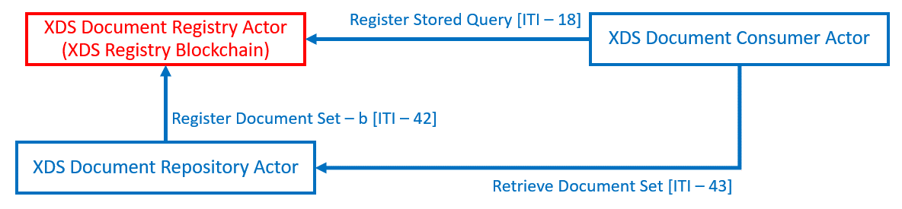

Figure ‑ XDS Profile within the scope of interest for this work

Following Section 2.1.4, all Blockchain nodes will receive ITI-42 transactions from their local XDS Document Repository Actor as normal XDS Document Registry Actor would do, before transitioning the transaction into Blockchain Smartcontract and publish into the Blockchain ledger. Likewise, the health document query via ITI-18 transactions from local XDS Document Consumer will be interpreted and interact with Smartcontract consecutively. Note that the XDS Document Consumer Actor will still be required to directly issue ITI-43 transaction to the XDS Document Repository Actor hosting the health document to retrieve it. The Smartcontract will act as a medium for each node to perform the task to add data, read data, and search for data within the Blockchain ledger (as shown in Figure 3‑2) allow the Blockchain technology to effectively integrated into the XDS system.

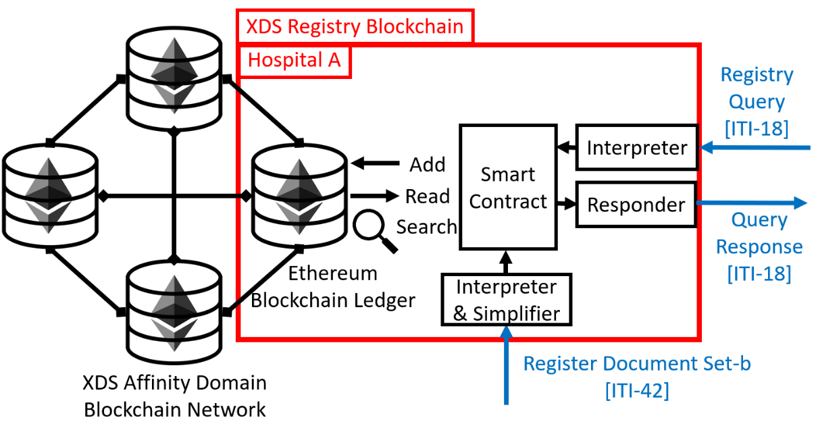

Figure ‑ Integrating Blockchain into XDS.b Profile

## 3.5 Design Functions

**3.5.1 Document Register**

This is where XDS Document Registry Actor registers health document metadata set within ITI-42 transaction received from XDS Document Repository into the Blockchain ledger. This function enables sharing of health documents to the XDS Affinity Domain Blockchain network as well as allowing the shared document to be registered as an alternative source. There are 2 Smartcontract functions related.

The first function is the document registering function, the function act as part of the XDS Document Registry Actor to store the value of health document metadata interprets from ITI-42 transaction into the Blockchain ledger. This function act in a fashion similar to a programming variable where certain values were assigned to a specific variable for usage within the program, a whole set of metadata value is assigned into single Smartcontract function transaction. The function also automatically assigns each set of metadata with an identification number to be used for common understanding amongst the Smartcontract to differentiate each set of metadata belong to each health document. The identification number also essential for search operation which would be further explained later.

The second function is the checker function which will check for the last identification number assigned to the published set of metadata. This function allows Smartcontract to keep track of the identification number previously used and prevent duplication. Each time a new set of metadata entering the Blockchain ledger, the identification number which would be assigned to the metadata set will be additively increased by 1 from the previous.

**3.5.2 Document Search**

The search operation allows members of XDS Affinity Domain Blockchain to discover health documents existing in the network by searching for registered metadata set belong to the document within the Blockchain ledger and gain access to actual documents using access information provided in the metadata. There are 2 Smartcontract functions related.

The first function is the read function where Smartcontract allows the XDS Document Registry Actor to read the value of metadata stored within the Blockchain ledger. This function only needs identification number input to return metadata value to the XDS Document Registry Actor program.

During the search operation, the XDS Document Registry Actor will be the one to handle the search keyword. The Actor performs sequential searches on each set of registered metadata using the assigned identification number for iteration until the matching result was found or reached the end of the iteration. The Actor then triggers the return query result function.

The second Smartcontract function is the return query result function where the Smartcontract returns the whole set of metadata specified as the search result to the XDS Document Registry Actor. The version of the return value omitted by this function is different from the read function in terms of compatibility with the ITI-18 transaction format. The XDS Document Registry Actor then sorts the result into an ITI-18 transaction and return it to the XDS Document Consumer Actor.

Following the normal process of IHE XDS.b Profile in Section 2.1.4, the XDS Document Consumer will then use health document access information provided within the search result metadata to gain access to the XDS Document Repository hosting the document. Then negotiate for document exchange using the ITI-43 transactions outside the Blockchain network.

As mentioned in Section 3.2, after receiving the document shared from its original source, the shared peer will also want to register the document into the XDS Document Registry to let the network know that now they can act as an alternative source of the document for the network.

## **3.6 Process Flow**

Figure 3‑3 showing the process flow of the XDS Document Registry Actor which acts as a medium between the Blockchain ledger and XDS System.

Flowchart Symbols

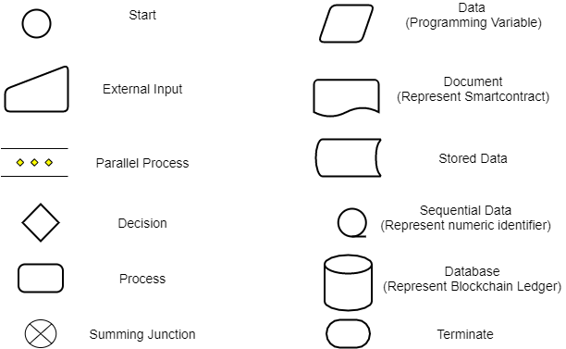

Figure ‑ The process Flow of XDS Document Registry Actor

**CHAPTER IV  
IMPLEMENTATION**

This chapter emphasizes the implementation step for this work. Begin with the setup method to establish a small Blockchain network for development which will describe the installation method and system specification. The second section then explains the implementation of each XDS Actor including its native programming code and corresponding Smartcontract detail. After that, the third section will explain the setup for the performance evaluation experiment and following with the experiment result in the last section.

## 4.1 Blockchain setup

**4.1.1 Machine Specifications**

For the implementation, the main machine was the best machine available for the implementation and compatible workflow which will be used for the coding process, which is a laptop Alienware 17 R5, Intel(R) Core (TM) i9-8950HK CPU@2.90GHz, 32 GB installed RAM, running on Windows 10 operating system version Home Single Language (20H2) 64-bit, x64-based processor. The code then deploys on the test machine. As most Ethereum-related software is initially designed for Linux OS, so Ubuntu was selected OS for the test machine. The test machine is where all Blockchain-related environment was deployed. A test machine is a virtual machine established within the main machine using Oracle VM VirtualBox. The virtual machine running on Linux Ubuntu (64-bit) version 18.10 with 8 GB RAM and 100 GB storage dynamically shared from the host main machine.

**4.1.2 Go-Ethereum**

Go-Ethereum or "Geth" client is the open sources software engine requiring to operate Ethereum Blockchain within each node. The client allows the user to issue commands to the node like initiate the Blockchain, start-stop mining/validating process for the Blockchain, and activate devp2p protocol to sync Blockchain data with other nodes. The client is available at [40]. Geth can be installed as standalone or included in the installation package of the Ethereum platform variant or other kinds of service interacting with Ethereum Blockchain (i.e., Ethereum Wallet Client). Geth's interface was initially designed to operate on Linux OS and later extend compatibility to other OS via Linux console simulated platform or work under graphic user interface of another client. The Geth client has no specific system requirement as it only is a set of Golang scripts that has no restriction to any system but, as it is mostly integrated within another client, so it requires the machine to compatible with the main client for installation. In the implementation, the test machine has Geth globally installed by installing Quorum, so the client can be launched from anywhere regardless of environment path.

Geth can be installed as standalone for ready the machine for working with Ethereum Blockchain using Linux installation from source repository command i.e., “apt-get install ethereum” in Ubuntu. The installation instruction can be located at [41]. Figure 4‑1 showing installation method for Ubuntu. All available command lines for Geth can be located at [42]. The most used command is "geth attach <IPC path or Link>" which required for accessing Geth console of each active node, as shown in Figure 4‑2. The console is where the user can input the command line to directly control the behavior of each Ethereum Node.

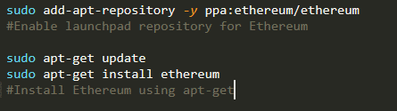

Figure ‑ Installation command-line for Go-Ethereum on Ubuntu [41]

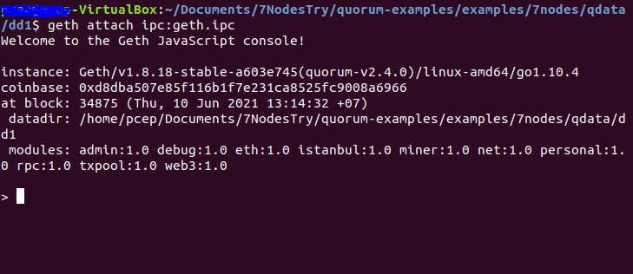

Figure ‑ Geth console accessed using "geth attach" command

**4.1.3 Quorum Installation**

As mentioned in Section 2.3.4.2, Quorum is an Ethereum-forked that allows the Blockchain to adopt a consensus mechanism other than PoW and PoS which default to Ethereum Blockchain. Quorum's source code and installation package can be accessed at [31]. The installation method for the latest stable release is located at [43]. The platform was designed to specifically operate with a Linux-based interface and can be compatible with non-Linux OS with the aid of 3rd party software as a medium. Other than that, the platform has no specific system requirement for installation. However, from the test during the implementation, it is recommended that the machine running Quorum should have more than 6 GB of available RAM. Otherwise, there will be a performance issue that occurred during the run. In this implementation, as the test machine running on Ubuntu 18.10, there is no other 3rd party software required to operate Quorum. The Geth client was included in the Quorum installation package, which means a developer can immediately start their Quorum Blockchain development right after the installation.

Figure 4‑3 showing the installation method for Quorum from its source which was used to install the latest stable Quorum released available at the time for the implementation. Some parts or functions used in the implementation may differ from the current released due to the version difference.

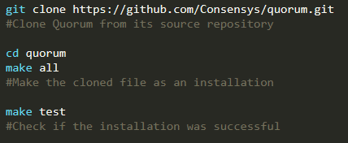

Figure ‑ Installing Quorum directly from its source

Other than the Blockchain platform, Quorum also offers the "7-Nodes Example" for developers to locally deploy in their machine to test the functionality and performance of Smartcontract during the development. The source code can be cloned directly from its repository available in Github [33] as shown in Figure 4‑4. The "7-Nodes" will simulate seven Blockchain nodes in the host machine in a similar fashion to a virtual machine using the required library called "Tessera" [44] and "Constellation" [45] included in the package as a running engine. The source code can be initiated, activated, and simultaneously controlled using the control script provided within the example. Each node can be accessed using the Geth client. For the implementation, the control script provided within the example was further modified to be compatible with our usage. The Blockchain initiation script was modified to be able to re-initiate the entire Blockchain by deleting the existing chain and replace with the empty one. This allows reset of published Blockchain during the development. The transaction publishing script was modified to run other specific code developed for XDS Document Registry Actor and its Smartcontract, allow testing and running of XDS Document registry-related code on the 7-Nodes. It must be noted that transaction-related scripts only operate on specified single nodes amongst the seven, not the entire set of the seven nodes. That means the activity of each node is independent.

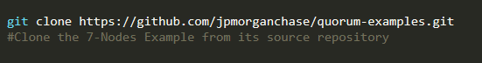

Figure ‑ Cloning "7-Nodes" Quorum example from its repository available on Github

All initial configuration instructions are available at [46]. Primarily, it is required to configure the genesis Block for the Blockchain ledger and issue the initiation command using the script provided in the example as shown in Figure 4‑5. Each script is specific for each consensus mechanism.

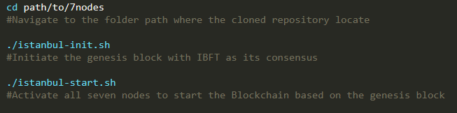

Figure ‑ Initial configuration method for 7-Nodes example

In this implementation, we only use the script "istanbul-init.sh" (execute using Linux Bash syntax as shown in Figure 4‑6) to initiate the genesis Block for the Blockchain ledger as we going to use IBFT as its consensus mechanism. The script will generate "istanbul-genesis.json" file as a configuration script for the genesis block which its content should be configured as shown in Figure 4‑7. Then the activation of the IBFT Blockchain can be done using "istanbul-start.sh" script as shown in Figure 4‑8 which will start the activation of all seven nodes and bring the 7-Nodes Blockchain network to become alive as shown in Figure 4‑9 and Figure 4‑10. It must be noted that this activation process may take several minutes.



Figure ‑ Executing "istanbul-init.sh" with Linux Bash syntax

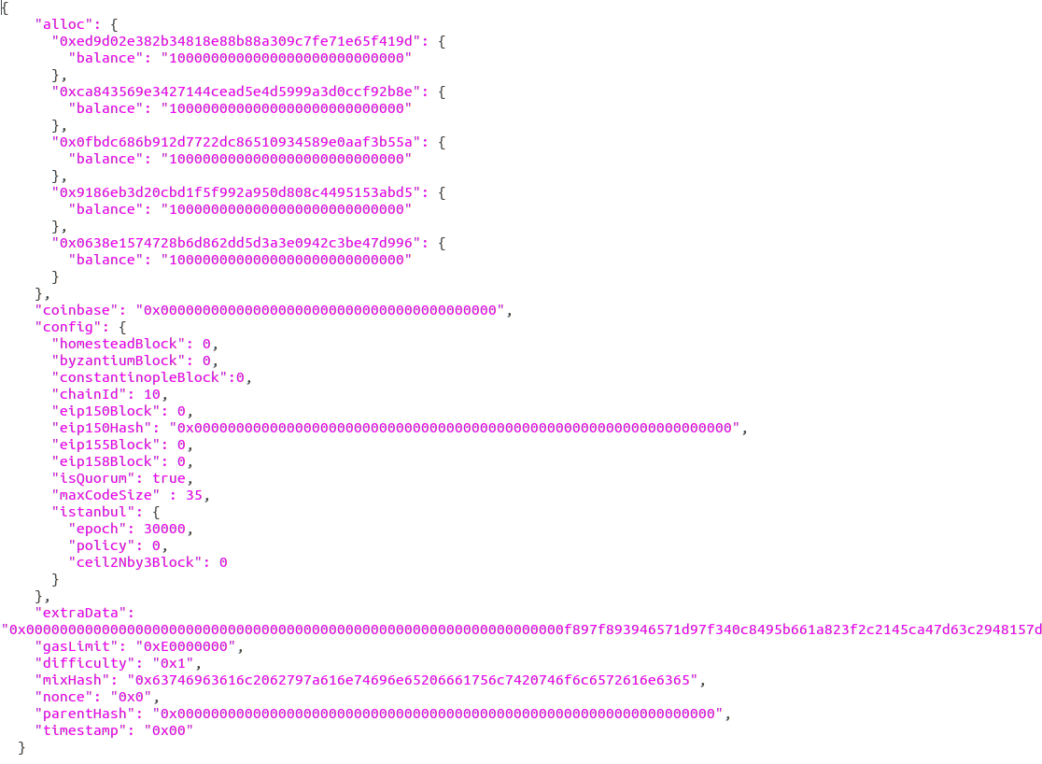

Figure ‑ Content of "istanbul - genesis.json" file

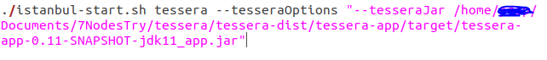

Figure ‑ IBFT 7-Nodes Blockchain activation script

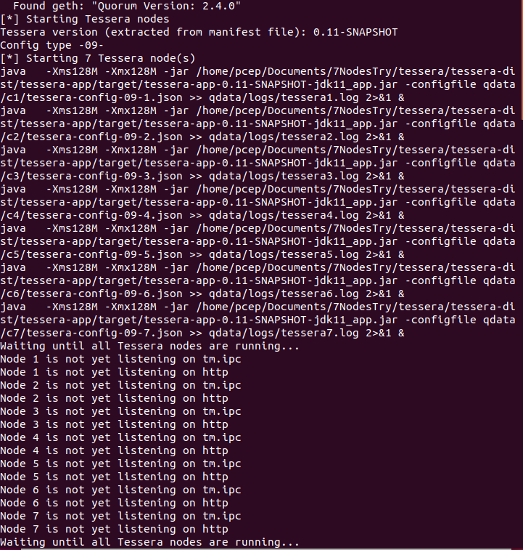

Figure ‑ The activation script activating all seven Blockchain nodes

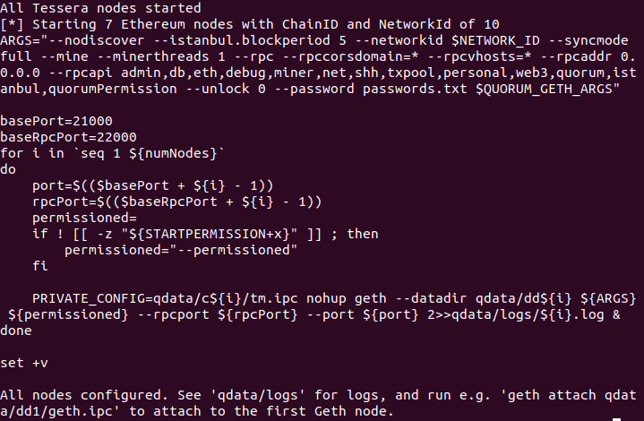

Figure ‑ All seven Blockchain nodes successfully activated

For this implementation, we further created a script to reduce the complexity of the initiation and activation process of 7-Nodes Blockchain. The script "rebirth.sh" will delete all data of an existing set of 7-Nodes Blockchain and initiate a new genesis file to simplify the reset of the Blockchain during the development of the implementation as shown in Figure 4‑11. The script "runmy7nodes.sh" will issue the whole command line required for activating the 7-Nodes Blockchain, simplify the Blockchain activation process as shown in Figure 4‑12. These scripts will help reduce the complexity of command-line manipulation during the implementation.

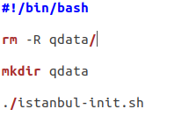

Figure ‑ The content of "rebirth.sh" script

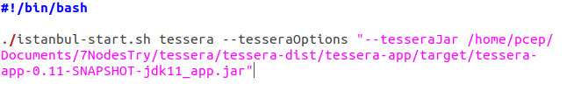

Figure ‑ The content of "runmy7nodes.sh" script

**4.1.4 Compile and Deploy Smartcontract Solidity Code**

For Smartcontract programming, Ethereum provides a web-based IDE for Solidity language that can compile, test, and deploy smart-contract to specific Ethereum node called “Remix” [47]. In the implementation, Remix was accessed using Google Chrome from the main machine and the session was saved locally using Remix client to avoid unexpected issues on the Solidity code. Each Smartcontract is validated, and test deployed within the IDE before actual implementation on the test machine. The Smartcontract ready for implementation will be compiled using the Solidity compiler provided by Remix community-based plugin. Each compiled solidity code gives ABI code and Binary code which will be used on Web3js code to interact with the Blockchain Smartcontract.

After successfully compiled the Solidity Smartcontract code, the ABI code and Byte code will be automatically generated by the IDE as shown in Figure 4‑13. These codes can be copied and passed into Web3js code by assigning a variable to store the code as its value like the example shown in Figure 4‑14 and Figure 4‑15. Noted that Byte code defines the behavior of the Smartcontract and only required on the first deployment of the Smartcontract which required only once in this implementation, while ABI code define interface for communicating with the Smartcontract and always required every time the native program communicate with Smartcontract.

Figure ‑ ABI Code and Byte code generated can be copied and passed directly

(From red circle) into Web3js code



Figure ‑ ABI code (brown color) assigned into variable "abi"



Figure ‑ Byte code (brown color) assigned into variable "bytecode"

**4.1.5 Deploy Smartcontract into Blockchain**

Before begin registering health documents metadata into Blockchain Smartcontract, the Smartcontract must be first deployed to act as a contract format for the entire Blockchain ledger for the implementation. Figure 4‑16 show the Web3js script that simply deploys the Smartcontract into the Blockchain ledger. It required both the Byte code and ABI code received from the Solidity compiler to be completed. Once the Smartcontract is deployed, any later communication with Smartcontract will only need ABI code to act as an interface for the communication. This Smartcontract deployment process only required once at the initiation of the Blockchain ledger and no longer needs to be performed ever again for the rest of the Blockchain ledger life cycle.



Figure ‑ The Web3js script for Smartcontract deploy

**4.1.6 Prepare NodeJS Coding Environment**

For the coding process of all non-Blockchain native Javascript programs, the coding environment must be provided essential coding components. In this implementation, we use NodeJS as a compiler and coding environment for all Javascript programs. NodeJS is available at [48]. The essential coding components node module can be installed using Node Package Manager (NPM) which comes together with NodeJS [49]. The coding of program for native side of XDS Actor require node module name "Web3" (Web3js) [50], "xml2js" [51], "fs" [52], "net" [53], "util" [54], "moment" [55], and "cryptr" [56] which can be installed using the command-line as shown in .



Figure ‑ "npm install" command-line

## 4.2 XDS Actors

As we have seen from HL7 and FHIR, current healthcare information exchanged related standards are mostly web-based protocol. Additionally, development of IT infrastructure to support healthcare operation require the capability to handle a huge amount of transaction in a limited amount of time so, it requires our system implementation to be able to handle multitask properly. With asynchronous nature and compatibility with website integration, Javascript is one of the best choices for our implementation of this work. In this implementation, we adopt the "Node.js" variant of Javascript as it was made to build scalable network applications that handle many connections concurrently. Furthermore, Node.js also providing simple access to community-made node modules which offer a wide variety of useful APIs for software development which may reduce difficulty in our implementation further.

All actors within IHE XDS Profile communicate with each other using XML message transaction. As we utilize Javascript as main programming language for the implementation, these XML messages need to be interpreted into programming object to allow simpler handling method within the program. Javascript Object Notation (JSON) is a lightweight data-interchange format of programming object which was invented to serve the purpose. It is easy for humans to read and write and easy for machines to parse or generate. That mean, all XML message transactions sent to XDS Document Registry actor program will be converted into JSON. For this implementation, we utilize NodeJS “xml2js” module for the task.

To connect our program to Ethereum smart contract, we can use Ethereum API tools which is Web3 [57] as a middle. Web3 allows smart contract control through preferred programming language and transitions logic and variables from the language to Solidity. Web3 provides a programming API for Javascript called "Web3JS" which allows the Javascript program to interact with Ethereum based smart-contract. The API can be accessed using the node module provided via Node.js.

### 4.2.1 XDS Document Repository Actor

4.2.1.1 Interpret IHE ITI-42 Transaction

Figure 4‑18, showing XML language code snippet of Registry Document Set-b [ITI-42] transaction sample. The code composing of two main sections. The first section labeled with “lcm:SubmitObjectRequest” is where XML schematic information are located and the label also act as marker which tell interpreter program to recognize it as ITI-42 transaction. The second section starts from label “rim:RegistryObjectList” following with “rim:ExtrinsicObject” contain all information regarding corresponding health document. This section is where all Metadata attributes of the document are located. If the Document Registry Actor successfully received the transaction, they must return response as shown in Figure 4‑18. The response transaction included only XML schematic information, message UUID number, and status type “successful” as shown in Figure 4‑19. This response will let the Repository finish its process and end messaging attempt. Figure 4‑20 show the actual code snippet using for the implementation.



Figure ‑ Pseudocode represents general format of Register Document Set-b [ITI - 42]



Figure ‑ XML Code snippet of Registry Document Set-b Response transaction sample













Figure 4‑20 XML Code snippet of Registry Document Set-b [ITI-42] transaction sample

4.2.1.2 XDS Document Repository Actor Simulating Program

For document registering, XDS Document Repository Actor register document Metadata attributes into XDS Document Registry Actor using IHE ITI-42 transaction. XDS Document Registry Actor then interprets the transaction into a programmable object before check if the transaction is ITI-42. Then, the actor proceeds to pass the retrieved object into Blockchain smart-contract and publish it into a Blockchain ledger. Figure 4‑21 showing the Javascript code snippet for the native side of XDS Document Repository Actor.



Figure ‑ Javascript Code Snippet of XDS Document Repository Actor

### 4.2.2 XDS Document Consumer Actor

4.2.2.1 Interpret IHE ITI-18 Transaction

Figure 4‑22, showing XML language code snippet of RegistryStoredQueryRequest [ITI-18] transaction sample. The code composing of   
3 main sections. The first section labeled “query:AdhocQueryRequest” is where XML schematic information are located and the label also act as marker which tell interpreter program to recognize it as ITI-18 transaction. The second section labeled “query:ResponseOption” mark the expected format of query result that will return to Document Consumer. The third section start from label “rim:AdhocQuery” contain all search keywords issued by Document Consumer. These search keywords are selected Metadata attributes and its value. When Document Registry Actor received the transaction, they will use search keyword provided to search for registry with matched Metadata attributes value then return the result to Document Consumer Actor as response transaction following Figure 4‑23 and Figure 4‑24. With header labeled “query:AdhocQueryResponse”, the transaction contain search result depend on query type specified in ITI-18 transaction. If the query expected for “LeafClass” as result, the response would return Metadata attributes of all matched result in detailed as shown in Figure 4‑23. Otherwise, if the query expected for “ObjectList”, the response would return object reference number of all matched result as shown in Figure 4‑24. These two types of response specifically selected depend on search behavior of Document Consumer Actor’s user. The query which specified “LeafClass” as its search result must provide keyword which unique to its corresponding document, such as document unique ID or object reference UUID. At the same time, “ObjectList” are used to search for wide range of document with generic search keyword and value where discovery of document existent is the main goal. Figure 4‑25 showing the actual ITI-18 transaction using in the implementation while Figure 4‑26 showing its actual response transaction.



Figure ‑ Pseudocode represents general format of Registry Stored Query Request [ITI - 18]



Figure ‑ Pseudocode represents general format of Query Response   
included “Object Reference” of search results





Figure ‑ Pseudocode represents general format of Query Response   
included "Leaf Class" of search result



Figure ‑ XML Code Snippet of RegistryStoredQueryRequest [ITI-18] Transaction Sample











Figure ‑ XML Code Snippet of RegistryStoredQueryResponse Transaction Sample

4.2.2.2 XDS Document Consumer Actor Simulating Program

For document query, XDS Document Consumer query for document Metadata attributes stored within XDS Document Registry Blockchain providing search operation type and some Metadata attributes value as search keyword via ITI-18 transaction. XDS Document Registry will check if the transaction is ITI-18 before performing search operation matching specified search type using provided keyword Metadata attributes value. The search operation will be performed by consequently call for each registered smart-contracts until all contracts with matched attributes value were found. XDS Document Registry Actor then returns all query result in XML format following specification for ITI-18 responding. Upon receiving the query response, XDS Document Consumer then interprets the transaction and displays the result to the user in a human-understandable format.

Following IHE XDS Profile, XDS Document Consumer actor is where the user specifies search keyword values of Metadata attributes for the system to query for matching document exist within XDS Affinity Domain. For this implementation, we design that the user interface will take the form of a command-line program that can be run via Windows command prompt or Linux terminal. The program will prompt the user to specify search type, including META-attributes value, and specify the value. The actor then accepts these values to create an XML message following ITI-18 format before sending it to a local or accessible XDS Document Registry actor to query for matching document and start search operation. Figure 4‑31 showing the Javascript code snippet for the native-side of the XDS Document Consumer Actor program.

The command-line interface of XDS Document Consumer begins with prompt the user to input registry query types (FindDocuments, FindSubmissionSets, FindFolders, GetAll, GetDocuments, GetFolders, GetAssociations, GetDocumentsAndAssociations, GetSubmissionSets, GetSubmissionSetAndContents, GetFolderAndContents, GetFoldersForDocument, GetRelatedDocuments, FindDocumentsByReferenceId, or choose to quit the program) as shown in Figure 4‑27. The user will need to specify digit numbers corresponding to the choice. Then, the user will be prompt to input essential metadata attributes required for the query type (i.e., FindDocuments will require attributes included DocumentEntryPatientId and DocumentEntryStatus as shown in Figure 4‑28) before prompt to input other metadata attributes as optional depending on the information the user known as shown in Figure 4‑29. When there are no more metadata attribute values to add, the user can choose to start a query for the document as shown in Figure 4‑30. The XDS Document Consumer Actor program will then accept the input and assort it into the ITI-18 transaction before sending it to XDS Document Registry Actor.

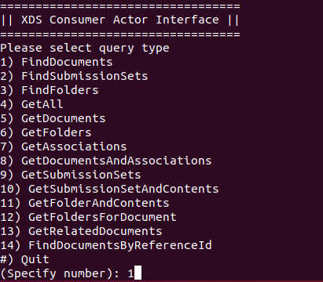

Figure ‑ The program prompt user to input query type

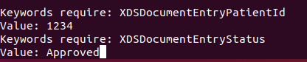

Figure ‑ The program prompt user to input essential metadata attribute values

(In case of FindDocuments query type)

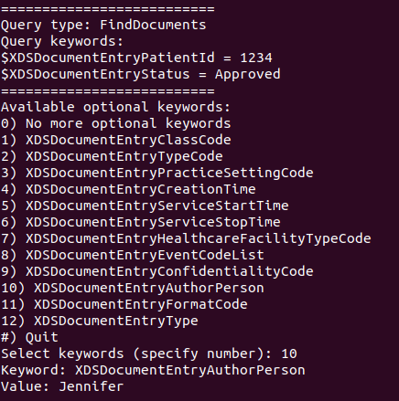

Figure ‑ The program prompt user to input optional metadata attributes

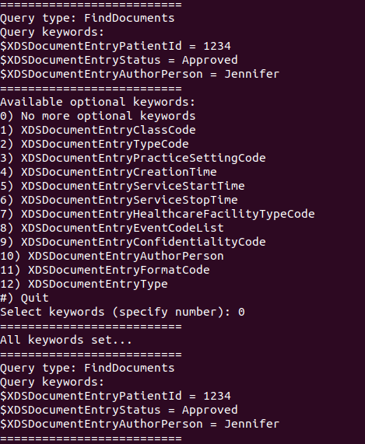

Figure ‑ The user chooses to start the query after input all known attributes

After the query has been sent, the XDS Document Consumer will wait for the response from XDS Document Registry Actor. When the response is received, the XDS Document Consumer then shows the metadata attributes the value of the query result in the terminal or just terminates the program if there is no matched result registered.





























Figure ‑ Javascript Code Snippet of XDS Document Consumer Actor

### 4.2.3 XDS Document Registry Actor

Following Section 3.5.1, the XDS Document Registry Actor program must be able to communicate with the simulated XDS Document Repository actor and XDS Document Consumer actor. At the same time, the software will need to act as the middle between the local XDS system and the Blockchain ledger. The completed process flow of the XDS Document Registry Actor is shown in pseudocode Figure 4‑32. The Actor will wait until receiving the XML message transaction and react differently to ITI-42 and ITI-18 transactions.



Figure ‑ Pseudocode showing the process flow of the XDS Document Registry Actor

Unlike the XDS Document Repository Actor and XDS Document Consumer Actor, the XDS Document Registry was made to act as the medium between the native system and the Blockchain Smartcontract. This section will break down the component of the XDS Document Registry Actor in a pattern different from the rest where it separated by its main function interacting with health document metadata which included Document Registering and Document Search. Each section will break down into Javascript native program part and Smartcontract part.

4.2.3.1 Implementing Document Register Function

4.2.3.1.1 Native-Side Javascript Program

For this implementation, the XDS Document Registry Actor will open a TCP connection to receive the transaction on a specified port. Upon receiving the ITI-42 transaction, the Actor then converts the XML message into JSON using xml2js. When ITI-42 was interpreted into JSON, the actor then assorts the object and sorts it into the Smartcontract compatible format. Figure 4‑33 is the pseudocode showing the process flow for the Javascript program handling the ITI-42 transaction until converted into the Smartcontract compatible format. Figure 4‑34 to Figure 4‑39 showing the Javascript code snippet of XDS Document Registry which is the part dealing with ITI-42 transaction and Document Registering Function.



Figure ‑ The pseudocode showing the process flow of XDS Document Registry Actor for Document Registering Function



Figure ‑ Javascript Code Snippet of XDS Document Registry Actor  
Node Module import declaration and TCP Socket message receiver section



Figure ‑ XDS Document Registry Actor  
This section checks if receiving message is ITI-42 or ITI-18 identified by its header





Figure ‑ XDS Document Registry Actor  
Declaration of JSON variable to store all Metadata attributes by its position in the format



Figure ‑ XDS Document Registry Actor  
Define variable of each Metadata attribute UUID label following IHE ITI Framework

















Figure ‑ XDS Document Registry Actor  
This section interprets and assort Metadata attribute value from ITI-42 to JSON







Figure ‑ XDS Document Registry Actor  
This section passes JSON into Smart Contract as single string variable

4.2.3.1.2 Smartcontract

In the implementation, Smartcontract was designed to store string values and will return the stored value when called by the corresponding Smartcontract function. The prepared JSON must be converted into a string variable before entering Smartcontract. This is due to the limit of the Ethereum Smartcontract which can cover a limited number of programming variables so, we simplify our program to avoid that limit by storing the whole JSON in string form as a single variable. As the Ethereum Blockchain requires a certain amount of gas to execute the Smartcontract, the length of the variable may cause an error in the process if there was not enough gas supplied. That means, we need to increase the limit amount of gas for executing Smartcontract from the default value as shown in Figure 4‑40. Although this change may not affect the implementation, it may affect the network where its member prefers to use actual cryptocurrency like Ether to maintain Blockchain where an increase in required gas may accelerate the depletion of currency circulating in the network and severely reduce the maintainability of the Blockchain. Figure 4‑41 showing the process flow of Smartcontract function related to Document Registering.

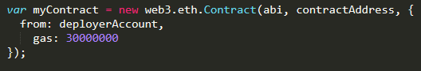

Figure ‑ Specified gas value spplying Ethereum Smartcontract execution



Figure ‑ The pseudocode showing the process flow of Document Register Smartcontract

By these Smartcontract design, XDS Document Registry actors can keep Metadata attributes of each document by storing them as JSON string variable inside Blockchain using one Smartcontract per document. At the same time, the actor can perform search operation by sequentially call upon each published Smartcontract one-by-one until the result was found or until the last in the case which no matching result. It must be noted that publishing of Smartcontract always requires gas to execute the task while calling for the variable value stored in the Smartcontract is not consuming any Blockchain resource. Figure 4‑42 showing the Solidity code snippet highlighting (green color) the part relating to Document Registering Function.



Figure ‑ Solidity Code Snippet of Smart Contract   
(Highlight - green color) related to Document Registering Function

4.2.3.2 Implementing Document Search Function

4.2.3.2.1 Native-Side Javascript Program

Like IHE ITI-42 transaction handling, the XDS Document Registry actors also wait for ITI-18 on the TCP channel. The received transaction will be converted into JSON while matching UUID with its corresponding metadata attributes as declared in Figure 4‑43. The transaction is specified with the header “QueryResponse” and compose of Metadata attributes value input by Document Consumer. These values will be used in search operation which will seek for the Smartcontract with matching metadata attribute values. After the result was found, the actor then proceeds to create a response XML message following the ITI-18 format. Figure 4‑44 showing the pseudocode describing the process flow for the native-side Javascript program related to Document Search. Figure 4‑45 to Figure 4‑49 show the Javascript code snippet for native-side of XDS Document Registry handling ITI-18 transaction and Document Search function.



Figure ‑ XDS Document Registry Actor  
Define variable of query request type UUID label following IHE ITI Framework



Figure ‑ The process flow for the native-side Javasceipt program

related Document Search Function









Figure ‑ XDS Document Registry Actor  
Identify query request type following received ITI-18 header and assort search keyword







Figure ‑ XDS Document Registry Actor  
Check for the latest document ID published in Blockchain before beginning search operation







Figure ‑ XDS Document Registry Actor  
Begin search operation by sequentially check each published contract one-by-one











Figure ‑ XDS Document Registry Actor  
Check if value of Metadata attributes in each publish contract matched with search keyword before summarize search result.





Figure ‑ XDS Document Registry  
Gather search result and response back to Document Consumer Actor

4.2.3.2.2 Smartcontract

Like the Document Register function, the XDS Document Registry Actor must be able to respond to the Document Search query from the Document Consumer by returning the metadata attributes of the registered document matched with the query to the consumer. In a traditional database, this can be done by utilizing a query of a relational (SQL) database. However, for Blockchain, the structure of stored data is different from relational databases but similar to NoSQL. That means search operation will need to rely on a sequential search algorithm. The program will need to take a look at all published transactions one-by-one from the first until the result was found. Each transaction will require the program to call on smart-contract for reviewing the stored value before comparing it with the specified value used for search. When all of the values called from the Smartcontract are matched with the value specified for search, the value called will be marked as a search result which will be returned to XDS Document Consumer Actor via ITI-18 format. Figure 4‑50 showing the pseudocode describing the process flow for the Smartcontract function related to Document Search. Figure 4‑51 showing the Solidity code snippet highlighting (green color) the part relating to Document Search Function.



Figure ‑ The pseudocode showing the process flow of Smartcontract function related to Document Search



Figure ‑ Solidity Code Snippet of Smartcontract

(Highlight - green color) related to Document Search Function

## 4.3 Implementation Result

As mentioned in Section 4.1.1, the environment of the test machine is running on Linux Ubuntu (64-bit) version 18.10 with 8 GB RAM and 100 GB storage dynamically shared from the host machine.

As mentioned in Section 4.1.3, the Blockchain network environment for the implementation will be demonstrated using the 7-Nodes Example Blockchain. That means there will be seven IBFT Blockchain nodes simulated within the environment of the test machine. The test sample will be monitored from node number one (which would later refer as “1st Node”).

To indicate that the implementation has the compatibility to operate with XDS Actors in a common XDS system, we created transaction samples based on the example provided by the IHE ITI framework. Transaction samples provided by the framework are including ITI-42 Register Document Set-b transaction, ITI-18 Registry Stored Query transaction and its corresponding response transaction. However, there is much more specification provided in the framework that far exceeds the element provided within the example so, there may consist of an element that differs from the transaction used in the actual system which may cause an error and need further adjustment in the actual deployment.

The main group of XDS Actors in the implementation are XDS Document Registry Actor, XDS Document Repository Actor, and XDS Document Consumer Actor as shown in Figure 4‑52. All files corresponding to the implementation must be included within the directory that contains the 7-Node Examples as shown in Figure 4‑52 in the bottom right window. As mentioned in Section 4.2.3 that the XDS Document Registry Actor is the actor that acts as the medium between the XDS system and the Blockchain network. At the same time, the main function and process triggered in the implementation including Document Register and Document Search (Document Query) are centered around the XDS Document Registry. The XDS Document Registry will always active and standby for incoming transactions as shown in Figure 4‑52 top left terminal and Figure 4‑53.

Figure ‑ All XDS Actors activated via its terminal  
(Top Left) XDS Document Registry Actor

(Top Right) XDS Document Consumer Actor

(Bottom Left) XDS Document Repository Actor

(Bottom Right) The folder containing all files related to the XDS Blockchain

Figure ‑ XDS Document Registry Actor standby and wait for incoming XML Messages.

As mentioned in Section 4.2.1 that the XDS Document Repository Actor is the actor that triggers the Document Register function registering new health document metadata attributes set into the Blockchain ledger. The Document Register function is triggered once the XDS Document Repository Actor program was called to register new health document metadata set into the XDS Affinity Domain network as shown in Figure 4‑54 and Figure 4‑55. The XDS Document Registry Actor then received the Document Register transaction and proceeds to broadcast the transaction into the Blockchain network publishing the transaction into the Blockchain ledger through a Block validation process as shown in Figure 4‑56. After the transaction was successfully published into the Blockchain ledger, the XDS Document Registry Actor response back to the Document Repository Actor to report that the process was completed as shown in Figure 4‑57 which terminating the XDS Document Repository Actor program.

Figure ‑ XDS Document Repository prompt for health document number to register

Figure ‑ XDS Document Repository sent ITI-42 transaction to XDS Document Registry

Figure ‑ XDS Document Registry received ITI-42 transaction and

successfully registered the metadata set into the Blockchain while wait for other XML Messages

Figure ‑ XDS Document Repository received response from XDS Document Registry

then terminate

As mentioned in Section 4.2.2 that the XDS Document Consumer Actor is the actor that triggers the Document Query function receiving user input search keyword values and asks the XDS Document Registry Actor to search for an existing registered document with the matching metadata attributes value as specified in the search keywords. Once called, the XDS Document Consumer Actor program will prompt the user for document query type (Figure 4‑58) then prompt for essential search keyword values (Figure 4‑59) and followed by the addition of optional search keyword values (Figure 4‑60). After all search keyword values from the user were set, the XDS Document Consumer Actor program then proceeds to assort the input into the ITI-18 transaction format and send it to the XDS Document Registry Actor as shown in Figure 4‑61. Upon receiving the transaction, the XDS Document Registry Actor program then uses the provided search keywords to search the Blockchain ledger for the metadata set with a matching value as shown in Figure 4‑62 and Figure 4‑63. Whether the matching result was found or not, after searching on all registered metadata set, the XDS Document Registry Actor then response search result to the XDS Document Consumer Actor as shown in Figure 4‑64. The XDS Document Consumer Actor then interprets the response and displays the search result to the user as shown in Figure 4‑65.

Figure ‑ XDS Document consumer Actor prompt the user for input

Figure ‑ XDS Document Consumer Actor prompt for essential search keyword values

Figure ‑ XDS Document Consumer Actor prompt for optional search keyword values

Figure ‑ XDS Document Consumer Actor sent ITI-18 transaction

to XDS Document Registry and wait for response

Figure ‑ XDS Document Registry received ITI-18 transaction then interpret the message

Figure ‑ XDS Document Registry then begin search operation over Smartcontract

If the matching result were found, it will be response back to XDS Document Consumer.

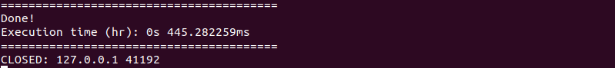

Figure ‑ XDS Document Registry responding search result back to XDS Document Consumer

Figure ‑ XDS Document Consumer received search result and display it to the user

## 4.4 Evaluation

The goal of the evaluation is to test the functionalities and the performance of the implemented system. This including the Document Register function and Document Query function. The evaluation will indicate the compatibility of the implemented system to an actual healthcare operation environment. The implemented system should be able to sustain a huge amount of data that continuously flows through the system without a failure. Each setup will be tested with the mockup transactions and measure the processing time required for the system to complete the specific process. There are ten transactions created for the experiment as test samples. Figure 4‑66 and Figure 4‑67 show an example of the mockup transaction created for the experiment and its full content can be further inspected in the Appendix Section. In each transaction have its metadata attributes named "DocumentEntry.patientId", "DocumentEntry.availabilityStatus" and some other attributes modified varied in each transaction for the test. All experiments will be tested with these transaction samples resulting as 10 times test for each setup ("transaction number #n" will be referred to as "Tx#n").

Figure ‑ Part of transaction samples content

Figure ‑ Ten of mockup transactions generated for the experiment

### 4.4.1 Functionalities Test

On the hypothesis that a changed number of active nodes may cause a change in the functionalities of the XDS Blockchain, to test the functionalities, the experiment performs by varying the number of nodes and test if the system could perform any function. Start from the setup with seven active nodes as the reference, followed by six, five, four, three, two, and one active node for the variation.

To create a situation where there are fewer than seven active nodes, the 7-Nodes Example configuration must be modified to meet the situation. In Quorum 7-Nodes Example, the number of active nodes was defined in the "permissioned-nodes.json" file as shown in Figure 4‑54. Each active node represents by its "enode" identifier number together with its communicating TCP port number as shown in Figure 4‑55. The node will become inactive if its enode number was excluded from the file. That means, in each setup for a specific number of nodes, enode number of inactive nodes must be excluded from the file before initiate the 7-Nodes Blockchain network. At the same time, the "numNodes" variable value in the "istanbul-init.sh" file must be set to the specific number of active nodes (i.e., numNodes = 6 for six active nodes) as shown in Figure 4‑56 to declare that there will be file directory prepared for the specified number of nodes at the initiation of the 7-Node Blockchain network.

After the configuration was modified, the 7-Nodes Example will automatically generate Blockchain nodes to meet with the specified number upon the initiation of the Blockchain ledger. That means every time the configuration file was modified for a new setup, the Blockchain network must be reset and re-initiated to ensure that there is no conflict with another setup which could affect the accuracy of the experiment result.

Figure ‑ Content of "permissioned-nodes.json" file define active nodes  
(node ids truncated for simpler explanation)



Figure ‑ Single node id represent single active node

Figure ‑ "numNodes" variable in "istanbul-init.sh" file reassigned with new value

Table 4‑1 shows that the system result from the implementation can function normally with 7, 6, and 5 active nodes. The system stops functioning when there are active nodes lesser than 5.

Table ‑ Functionalities experiment result

|  |  |  |  |  |  |  |  |
| --- | --- | --- | --- | --- | --- | --- | --- |
|  | 7 Nodes | 6 Nodes | 5 Nodes | 4 Nodes | 3 Nodes | 2 Nodes | 1 Nodes |
| Smartcontract Deployment | ✓ | ✓ | ✓ | 🗶 | 🗶 | 🗶 | 🗶 |
| Document Register | ✓ | ✓ | ✓ | 🗶 | 🗶 | 🗶 | 🗶 |
| Document Query | ✓ | ✓ | ✓ | 🗶 | 🗶 | 🗶 | 🗶 |

After looking into the root cause of the result, it is turn out that the 7-Nodes Example cannot resolve the Block validation process cycle in a situation with fewer than 5 active nodes. Figure 4‑71 shows the content of the log file monitoring the 7-Nodes example process where the upper red rectangle shows the beginning of the network while the lower red rectangle shows the process stopped at the initiation of the first Block validation process. The log shows that the Block validation process cycle which would repeat continuously and endlessly simply stopped at the first Block and there is no further upcoming process appeared in the log or none of any error notification appeared.

Noteworthy, this is not even related to the condition of IBFT consensus where it requires at least 2/3 of all nodes to vote for the same Block version to complete the validation process. The system should be able to operate normally without error even there are fewer than 5 active nodes when all active nodes agreeing on the same Block version and there is no "bad actor node" present in the system to propose a falsified Block version that interrupts the vote

We think that a possible reason could be that the 7-Nodes example may not be developed for the situation with 4,3,2, or 1 active node as it was only built to aid Smartcontract developers to easily deploy and test their Smartcontract in the proper 7 active nodes simulated environment closely similar to the actual Blockchain network.

Figure ‑ The 7-Node Example system log

It also must be noted that it is possible for the case that contains an even number of nodes may cause failure in Block validation attempt due to the majority of Block approval from nodes not meet the least requirement of 2/3 of all nodes in the network. For example, if ten nodes are participating, five nodes proposed Block named 'ABC' while another five nodes proposed Block named 'CBA'. This example will result in failed Block validation attempt. If this happened, the network was expected to try another attempt until the majority meet the least requirement of 2/3 and all the remaining transactions were successfully added into the valid Block and published into the Blockchain ledger. However, the evaluation of the implementation will not cover the case due to complications in creating the “bad actor” node. We assume that the feature was not directly included with Ethereum, Quorum, or its 7-Nodes Example as it was not created for a malicious purpose so, it is too difficult for us to create the situation that half of the participate nodes attempt to propose falsified Block for the evaluation.

### 4.4.2 Performance Test

On the hypothesis that a changed number of active nodes or change in the amount of XDS transactions entering the system may cause a change in the performance of the XDS Blockchain, the performance test will be performed by triggering the Document Register function and/or the Document Query function depends on the setup. The prepared transaction samples will be tested on the setup with a specific number of nodes then measure the time the system took to complete the process. Additionally, to increase the accuracy of experiment results and reduce the effect from other factors outside the consideration, the experiment will be repeated ten times on each transaction sample. The final performance result of each transaction will be derived from the average values of these ten times repeated.

As mentioned in Section 4.4.1 that the 7-Nodes example only functions normally with 7, 6, and 5 active nodes, so the performance test with a varied node number only possible for the case with the specified active nodes.

4.4.2.1 Test if the number of search keywords would cause a change in performance of Document Query function.

This setup is performed by trigger the XDS Document Consumer Actor to start the Document Query function which prompts for input from the user. The user then inputs metadata attributes values of each transaction sample (Tx1 – Tx10) into the program. The program then proceeds to query for the matching metadata set registered in the Blockchain ledger from the XDS Document Registry Actor in the 1st Node (only one active node received the query). The processing time since the moment the XDS Document Consumer Actor sent the ITI-18 transaction to the XDS Document Registry Actor until the XDS Document Consumer received the search result from the XDS Document Registry will be measured for the experiment result. The "minimum" search keywords will include only two attribute values while the "maximum" search keywords will include fourteen attribute values. Both will be performing the "FindDocument" query type which is the only stable query type available in the current version of the implementation.

The Document Query with minimum keywords took an average process time of 302.5096151 milliseconds to complete the function. The Document Query with maximum keywords took an average process time of 298.9329658 milliseconds to complete the function. Figure 4‑72 show no significant difference between the Document Query with maximum search keywords compared to the Document Query with minimum search keywords. That means the amount of search keywords input is not affecting the performance of the Document Query function. A full version of the experiment result can be further inspected in the Appendix section.

Figure ‑ Process time required to complete the Document Query

compared between minimum keywords and maximum keywords

4.4.2.2 Test if number of active nodes would cause change in performance of Document Register function

This setup is performed by trigger the XDS Document Repository Actor to start the Document Register function which will send the ITI-42 transaction containing metadata attributes set of the selected document (Tx1 - Tx10) to the XDS Document Registry Actor of the 1st Node (only one active node received the register). The processing time the XDS Document Registry took to complete the process publishing the metadata attributes set into the Blockchain ledger will be measured for the experiment result.

With 7 active nodes, the 1st Node XDS Document Registry Actor took an average processing time of 3.65415466 seconds with the maximum processing time at 4.172552233 seconds and the minimum processing time at 2.880175005 seconds.

With 6 active nodes, the 1st Node XDS Document Registry Actor took an average processing time of 4.573630153 seconds with the maximum processing time at 5.391518249 seconds and the minimum processing time at 4.245366876 seconds.

With 5 active nodes, the 1st Node XDS Document Registry Actor took an average processing time of 5.954575049 seconds with the maximum processing time at 6.37163004 seconds and the minimum processing time at 5.273704735 seconds.

Figure 4‑73 compares the processing times the system took to complete the Document Register function which shows that there is a slight difference in performance between each node number variation setup. The lesser number of active nodes, given longer processing time. This means the variation in node number is affecting the performance of the system.

Figure ‑ Performance comparison of Document Register on node number variation setup

4.4.2.3 Test if each active node has the same performance on performing the Document Register function when all active nodes perform the Document Register function at the same time.

This setup is performed by trigger the XDS Document Repository Actor to start the Document Register function which will send the ITI-42 transaction containing metadata attributes set of the selected document (Tx1 - Tx10) to the XDS Document Registry Actor of all active nodes (all active nodes received the register). The processing time the XDS Document Registry took to complete the process publishing the metadata attributes set into the Blockchain ledger in each active node will be measured for the experiment result. The experiment was further performed by varied active nodes number to check if there are any differences in the experiment result which is further explained in Section 4.4.2.4.

With 7 active nodes, to complete the Document Register function, the 1st Node took an average processing time of 6.694740502 seconds. The 2nd Node took an average processing time of 6.64481847 seconds. The 3rd Node took an average processing time of 6.697508806 seconds. The 4th Node took an average processing time of 6.892059017 seconds. The 5th Node took an average processing time of 7.026599076 seconds. The 6th Node took an average processing time of 6.695705492 seconds. The 7th Node took an average processing time of 6.631355668 seconds. All active nodes show no significant difference in performance to complete the function as shown in Figure 4‑74.

With 6 active nodes, to complete the Document Register function, the 1st Node took an average processing time of 7.261896542 seconds. The 2nd Node took an average processing time of 7.03144854 seconds. The 3rd Node took an average processing time of 7.14090967 seconds. The 4th Node took an average processing time of 7.137407174 seconds. The 5th Node took an average processing time of 7.05559841 seconds. The 6th Node took an average processing time of 7.087177031 seconds. All active nodes show no significant difference in performance to complete the function as shown in Figure 4‑75.

With 5 active nodes, to complete the Document Register function, the 1st Node took an average processing time of 7.289964378 seconds. The 2nd Node took an average processing time of 7.232330579 seconds. The 3rd Node took an average processing time of 7.27142245 seconds. The 4th Node took an average processing time of 7.150316791 seconds. The 5th Node took an average processing time of 7.146553912 seconds. All active nodes show no significant difference in performance to complete the function as shown in Figure 4‑76.

Figure ‑ Performance comparison inspected from each node in 7 Nodes setup

Figure ‑ Performance comparison inspected from each node in 6 Nodes setup

Figure ‑ Performance comparison inspected from each node in 5 Nodes setup

4.4.2.4 Test if the number of active nodes would cause a change in the performance of the Document Register function when all active nodes perform the Document Register function at the same time.

This setup is a further analysis result of Section 4.4.2.3. The "7 Nodes" line was derived from the average values of the experiment result in Figure 4‑74. The "6 Nodes" line was derived from the average values of the experiment result in Figure 4‑75. The "5 Nodes" line was derived from the average values of the experiment result in Figure 4‑76.

Figure 4‑77 shows the performance comparison between each node number variation setup when all nodes triggering the Document Register function at the same time. The graph shows no significant difference between each setup which means that node number variation is not affecting the system performance on performing the Document Register function when all nodes trigger the function at the same time.

Figure ‑ Performance comparison of average process time for each node number variation setup

4.4.2.5 Test if the number of transactions would cause a change in performance of the XDS Document Registry to perform the Document Register function.

This setup is a further analysis result of Sections 4.4.2.2 and 4.4.2.4. In Figure 4‑78, the "Single Node" line was derived from the average values of the experiment result in Figure 4‑73. The "All Nodes" line was derived from the average values of the experiment result in Figure 4‑77.

Figure 4‑78 shows that when all nodes perform the Document Register function at the same time, it took a slightly longer time to complete the function when compared to the situation when there is only a single node perform the Document Register function.

Considering the Document Register function, it is where each node gathers all transactions broadcasted into the Blockchain network at the time to put into the same Block and validate it for entering the Blockchain ledger. Whether there is a huge number of transactions entering the Blockchain or none, it should not be affecting the performance of each Blockchain node in performing the Document Register function. So, it is possible that the difference in performance shown in Figure 4‑78 was a result of another factor.

Consider the nature of the 7-Nodes Example which its Blockchain nodes need to share processing units of the same host machine. The shared processing unit environment may be affecting the performance of each node resulting in a slight difference in performance.

Figure ‑ Performance comparison between   
when only a single node performs the Document Register   
and when all nodes perform the Document Register at the same time

4.4.2.6 Test if each active node has the same performance on performing the Document Register function when all active nodes perform the Document Register at the same time with Document Query.

This setup is performed by a method like Section 4.4.2.3 with the addition of performing the Document Query function at the same time as the Document Register function. The processing time the XDS Document Registry took to complete the process publishing the metadata attributes set into the Blockchain ledger in each active node will be measured for the experiment result.

With 7 active nodes, to complete the Document Register function, the 1st Node took an average processing time of 10.91860947 seconds. The 2nd Node took an average processing time of 11.16871924 seconds. The 3rd Node took an average processing time of 10.75588351 seconds. The 4th Node took an average processing time of 10.95396888 seconds. The 5th Node took an average processing time of 10.9228691 seconds. The 6th Node took an average processing time of 11.08287522 seconds. The 7th Node took an average processing time of 10.88583567 seconds. All active nodes show no significant difference in performance to complete the function as shown in Figure 4‑79.

With 6 active nodes, to complete the Document Register function, the 1st Node took an average processing time of 9.958971148 seconds. The 2nd Node took an average processing time of 10.00410103 seconds. The 3rd Node took an average processing time of 10.07019995 seconds. The 4th Node took an average processing time of 10.12037286 seconds. The 5th Node took an average processing time of 9.624050698 seconds. The 6th Node took an average processing time of 9.993514932 seconds. All active nodes show no significant difference in performance to complete the function as shown in Figure 4‑80.

With 5 active nodes, to complete the Document Register function, the 1st Node took an average processing time of 9.784849326 seconds. The 2nd Node took an average processing time of 9.632056128 seconds. The 3rd Node took an average processing time of 9.813556105 seconds. The 4th Node took an average processing time of 9.420612465 seconds. The 5th Node took an average processing time of 9.451288139 seconds. All active nodes show no significant difference in performance to complete the function as shown in Figure 4‑81.

Figure ‑ Performance comparison inspected from each node in 7 Nodes setup   
trigger both Document Register and Document Query

Figure ‑ Performance comparison inspected from each node in 6 Nodes setup   
trigger both Document Register and Document Query

Figure ‑ Performance comparison inspected from each node in 5 Nodes setup   
trigger both Document Register and Document Query

4.4.2.7 Test if the number of active nodes would cause a change in the performance of the Document Register function when all active nodes perform both the Document Register function and Document Query function at the same time.

This setup is a further analysis result of Section 4.4.2.6. The "7 Nodes" line was derived from the average values of the experiment result in Figure 4‑79. The "6 Nodes" line was derived from the average values of the experiment result in Figure 4‑80. The "5 Nodes" line was derived from the average values of the experiment result in Figure 4‑81.

Figure 4‑82 compares the processing times the system took to complete the Document Register function which shows that there is no significant difference in performance between each node number variation setup. This means the variation in node number is not affecting the performance of the system when performing both the Document Register and Document Query at the same time.

Figure ‑ Performance comparison of average process time for each node number variation setup

4.4.2.8 Test if perform the Document Register at the same time with Document Query would cause a change in performance of the system to complete the Document Register function.

This setup is a further analysis result of Sections 4.4.2.4 and 4.4.2.7. In Figure 4‑83, the "without Query" line was derived from the average values of the experiment result in Figure 4‑77. The "with Query" line was derived from the average values of the experiment result in Figure 4‑82.

Figure 4‑83 shows significant difference between each setup which means that triggering the Document Query function at the same time as the Document Register function is affecting the performance of the system to perform the Document Register function.

Figure 4‑79 to Figure 4‑81 and Figure 4‑83 shows that the system took a longer processing time as it proceeds to perform the Document Register function of each transaction sample when performing the Document Query function at the same time. The system also causes the test machine to freeze or show functional error after processed the Tx5 transaction set (10 times each). The Blockchain was forced to be reset to continue the experiment for Tx6 to Tx10. After investigation, we think that performing the Document Register and Document Query function at the same time causes the 7-Nodes Blockchain to accumulate redundancy over time. This should be fixed with further optimization of the XDS Document Registry Actor program.

Figure ‑ Performance comparison between trigger the Document Register function,   
with and without the Document Query function

4.4.2.9 Test if the number of active nodes would cause a change in the performance of the Document Query function.

This setup is performed by a method like Section 4.4.2.1 with the addition of node variation setup (with 7,6, and 5 active nodes) and perform only for the search with minimum number of search keywords. The processing time since the moment the XDS Document Consumer Actor sent the ITI-18 transaction to the XDS Document Registry Actor until the XDS Document Consumer received the search result from the XDS Document Registry will be measured for the experiment result.

Perform Document Query without the Document Register function, with 7 active nodes, the processing time the system took to complete the Document Query is an average of 302.5096151 milliseconds. With 6 active nodes, took an average of 259.7879338 milliseconds. With 5 active nodes, took an average of 244.2096615 milliseconds. Figure 4‑84 show a performance comparison between each setup.

Perform Document Query at the same time as the Document Register function, with 7 active nodes, the processing time the system took to complete the Document Query is an average of 7.650895793 milliseconds. With 6 active nodes, took an average of 5.760202558 milliseconds. With 5 active nodes, took an average of 4.167169248 milliseconds. Figure 4‑85 show a performance comparison between each setup.

Both Figure 4‑84 and Figure 4‑85 show the difference between each setup that means node number variation is affecting the system performance on performing the Document Query function. The graph suggests that the lower active nodes took a slightly shorter processing time to complete the Document Query function.

Figure ‑ Performance comparison of Document Query on node number variation setup  
without trigger Document register

Figure ‑ Performance comparison of Document Query on node number variation setup  
with Document register triggered at the same time

4.4.2.10 Test if the number of transactions would cause a change in performance of the system to perform the Document Query function.

This setup is a further analysis result of Sections 4.4.2.9. In Figure 4‑86, the "Single Node" line was derived from the average values of the experiment result in Figure 4‑84. The "All Nodes" line was derived from the average values of the experiment result in Figure 4‑85.

Figure 4‑86 shows a significant difference in the performance of the system to perform the Document Query function.

This can be explained as the Document Query function relies heavily on the computational power of the XDS Document Registry Blockchain node to complete the search operation. The node can perform the search operation for the Document Query function at a slower rate when the node needs to spend a portion of computational power on the Document Register function at the same time. However, the performance can be further improved by improving the programming sequence of the XDS Document Registry program or assign another processing unit to trigger the Document Register function separated from the unit that triggers the Document Query function.

Figure ‑ Performance Comparison between trigger Document Query,   
with and without Document Register

**CHAPTER V  
DISCUSSION AND CONCLUSION**

This chapter comprises two main sections including the discussion and conslusion.

**5.1 Discussion**

Amongst many metadata attributes, there are attributes that value can expose patients' confidential information into the Blockchain network. For example, "DocumentEntry.sourcePatientInfo" contains demographic information of the source patient to whose medical record the document belongs. The attribute can contain multiple values such as patient name and address. So, in the actual adoption of the proposed concept, these metadata attributes values must be anonymized before entering the Blockchain ledger. This can be done by replacing the value with its hash counterpart when the attributes entering the Blockchain ledger via the Document Register function. At the same time, when the attributes were required for the search operation as search keywords input, the XDS Document Consumer will only need to hash the input value and use the hash to allow the XDS Document Registry actor to search for the matching hash value registered within the Document Registry Blockchain. This allows the concept to maintain confidentiality of patients' data while preserving the functionalities of the concept.

During the study on the IHE Profiles standard, we found that the complexity of the IHE standard gave difficulty for interpretation. There are a lot of components including transaction formats, data structures, and specific protocols that are specifically designed for each IHE Profile that published separately in different volumes of IHE Framework documents. Some part of the document was deprecated or obsoleted in the present. There are a limited number of transaction samples available from the framework which makes it difficult for a beginner to develop a system that fully complies with the standard. These make the standard implementation the most time-consuming process.

For Ethereum, the usage of Smartcontract was limited by its gas requirement. Every task performed by Smartcontract requires gas which represents the computational power of the network to perform. That means there will be more factors for the platform to be addressed before the actual adoption. We suggest that the adopted network must be able to provide enough amount of gas or disregard the component from the consideration by integrating it into the common agreement amongst the networks.

**5.2 Conclusion**

In this work, we achieve the system prototype for the XDS Blockchain which acts as the medium for health document sharing amongst the XDS Affinity Domain Network. The prototype was designed to be compatible with normal XDS Actors while also act as a medium for a common XDS network to interface with the IBFT Blockchain ledger. This enhances the IHE XDS.b Profile with the Blockchain characteristics while appreciating the network to further share their health document to further benefit from the network for both operational interoperability and cyber-security. However, due to the ever-changing nature of the software platform, further adoption of the implementation will need to be updated as the platform released the newer version of the software to avoid version conflict of the source code.

In the implementation of the proposed concept, we excluded an XDS On-Demand Document Repository Actor and XDS Patient Identity Feed actor to reduce the complexity of the concept demonstration. For future work, those XDS Actors should also be implemented to the XDS Blockchain concept too. The XDS On-Demand Document Repository would enhance the benefit of the XDS Blockchain as it provides On-Demand health document type which gave flexibility and a wider range of usability of shared health documents to healthcare operation. At the same time, The Patient Identity Feed Actor would aid the member of the XDS Affinity Domain Blockchain network by establishing the medium identifier for all members to seamlessly share their health documents. The Patient Identity Feed Actor may even further integrate into the Smartcontract and eliminate the need for centralized identity feed in the network. Eliminate the cost which would be spent on maintaining the Patient Identity Feed Actor for the network. Furthermore, the Smartcontract also has the potential to become the exchange medium for ITI-43 transactions where the XDS Document Consumer negotiates with XDS Document Repository for retrieving actual health documents, allow health documents exchanging activities in the network to be recorded in the Blockchain ledger which could be further used in the incident investigation during the cyber-incident. These would maximize the potential of Blockchain technology implemented on the Cross-Enterprise Document Sharing Profile.

Other than the Cross-Enterprise Document Sharing Profile, the IHE IT Infrastructure is providing much more profiles and various tools for use in achieving healthcare interoperability. There remain a lot more possibilities of using the framework to maximize the potential of Blockchain technology and the future technology to come.

As Blockchain technology still has a long way of development and research path to go through, the concept proposed in this work also could be further developed into a more advanced version for actual adoption in the future.